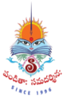
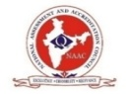
SITAM
SATYA INSTITUTE OF TECHNOLOGY AND MANAGEMENT
Gajularega, Vizianagaram, Andhra Pradesh, India-535002.
Accredited by "NAAC"
Approved by AICTE and Affiliated to JNTUK, KAKINADA
Email: sitam@sitam.co.in, Website:www.sitam.co.in
Telephone No:9676788811, 8978812341/2, Land Line: 08922-234775
IQAC- SATYA INSTITUTE OF TECHNOLOGY AND MANAGEMENT
Qualitative Metrics
Criterion 7-Institutional Values and Best Practices
7.1.8 | The tolerance and harmony towards cultural, regional, linguistic, communal socioeconomic and other diversities

To promote concord and tolerance toward cultural, regional, linguistic, communal, and other socioeconomic diversity, SITAM offers an inclusive atmosphere. All people are urged to hold their hate and hatred in check at all times as a preliminary practise.

SITAM is aware that in order to make India a strong, truthful, and vibrant nation, all of its stakeholders must find inspiration in the great sons and daughters of India. Recognizing this, SITAM organises national holidays, commemorations of the births and deaths of notable Indians, and the majority, if not all, of significant dates of historical, cultural, local, and regional significance, some of which are listed below:
- Independence day
- Republic day
- Yoga Day
- Makar Sankranti
- Diwali

The institute acknowledges the significance of national holidays, as seen by the fact that all celebrations include inspirational and motivational lectures and other cultural events, along with activities.

The pluralism and diversity of India are upheld by festivals, which are observed in such spirit. Diwali is observed with a programme of sweets distribution and wish-exchange. Yoga sessions are provided for the faculty on Yoga Day and are open to everyone.

Religious holidays and local festivals are organised with humour and a lot of student participation. To put Indian cultural legacy in the proper perspective and instil in students and employees a sense of duty to the nation, prominent philosophers often deliver lectures.

In order to provide students a comprehensive understanding of India and to provide them with important insight into official protocol and procedures, senior officials from businesses or government agencies are invited to speak to students on special occasions whenever possible.

75th Independence Day celebrations at SITAM
Date:15-08-2021
The national tricolor was unfurled amidst festive gusto in the SITAM campus in Vizianagaram. Chairman of Stayfit Health and Fitness World Pvt Ltd,Bangalore , Dr. G. K. Ganapati and Chairman of Vision Digital India, Bangalore Mr. Harikrishna unfurled the national flag and addressed the audience on the occasion. Besides the NCC Marching parade , the acrobatics performance of NCC cadets and various performances by the students stood as special attractions in the celebrations. In addition the students performed song and dance sequences to depict our culture of patriotism. In this glorious event jointly organized by Satya Institute of Technology and Management, several prizes were given away for the winners in various sports events. As a tradition, Government servants, Social Activists and Philanthropists were honoured along with distinguished Alumni. Dr M. Priyanka of MR Hospital, Dr. Divya Deepti of Ghosha Hospital were among the honoured. Distinguished alumni Sri M. A . Naidu, currently working as Jailer in Eluru and Smt T. Chittemma currently working as Constable in Vizianagaram Rural Police Station were specially honoured for their unflinching service during the Covid pandemic period.
Recognizing the contributions in the relief operations during the pandemic, founder of Spark Society gave away mementos to 50 NCC cadets of the Institute.
Smt. Srilakshmi, Social activist and president medal winner and Mr. Ram , MD of stay fit also participated and shared their life experiences and wished the students to come up in life in their chosen fields by staying fit Physically and Mentally.
Chairman and Secretary and Correspondent of Satya Group of institutions, Sri Botcha Satyanarayana and Smt. Dr. Botcha Jhansi Lakshmi sent their Greetings and Best Wishes on the occasion.

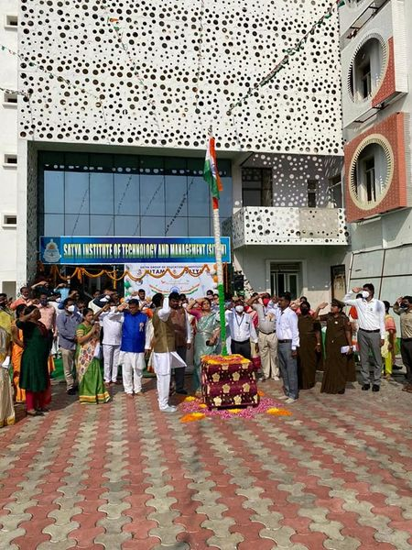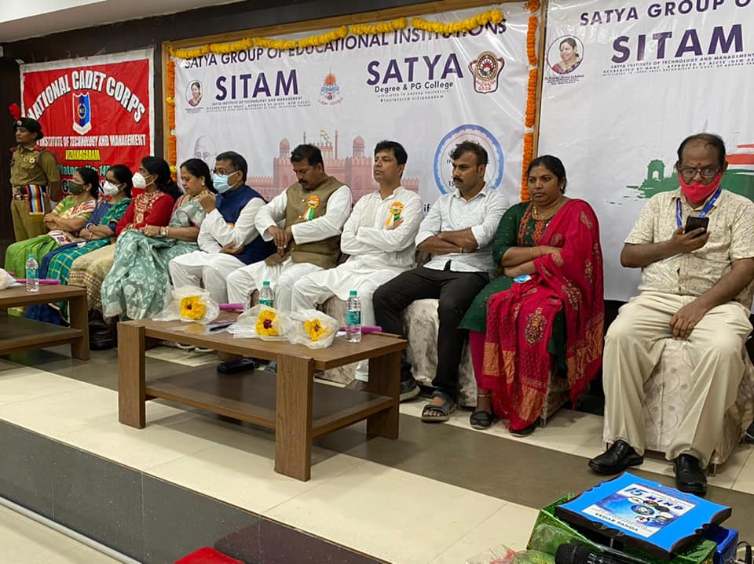

Name of the Event: Teachers' Day at SITAM Engineering College

Date:05-09-2021
Teachers' Day was celebrated in the divine memory of Sri Sarvepalli Radha Krishnan at SITAM Engineering College. On this occasion games, songs, dance, and cursive competitions were organized for the teachers. Prizes were presented to the winning teachers in the competitions held on this occasion. Special prizes were awarded to those who published research articles and to those who wrote textbooks. Dance performances of Sri. Dosapati Chaitanya and Karunakar impressed everyone with all the performances. College Chairman Sri. Dr. Botcha Satyanarayana, Secretary and Correspondent Dr. Botcha Jhansi Lakshmi sent messages of congratulations and the choreography performed by the students as part of the program made everyone happy
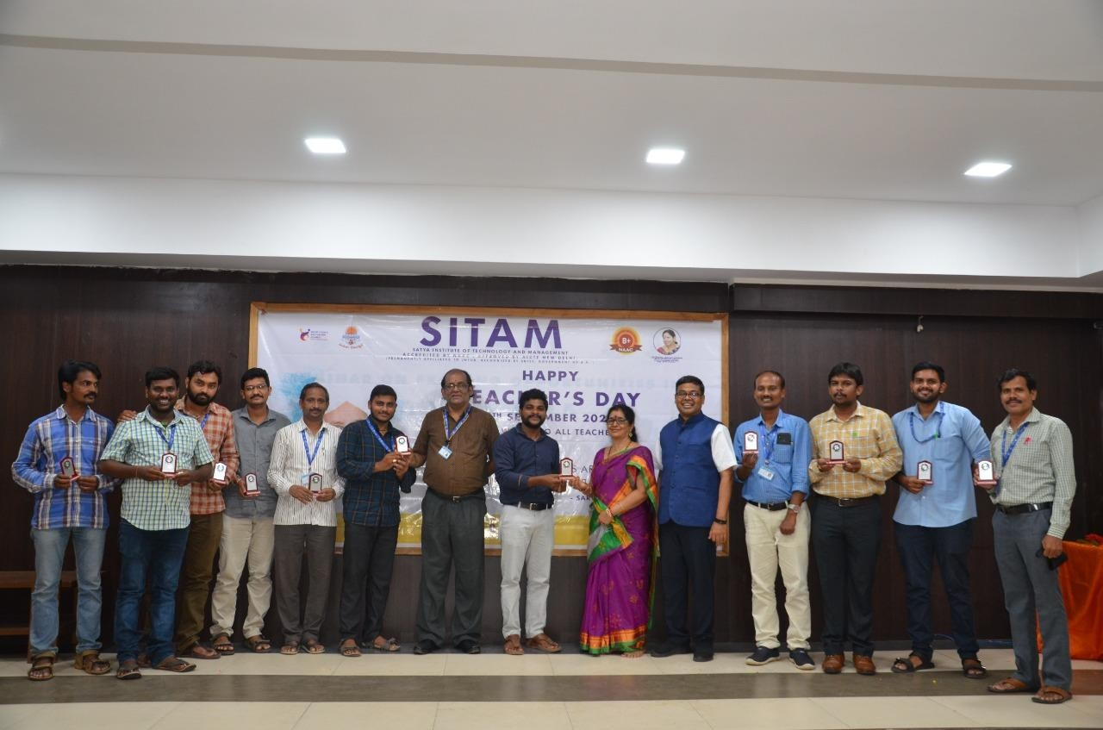

DIWALI CELEBRATIONS
Date:04-11-2021
Diwali Festival was celebrated in the campus of SITAM College, Vizianagaram on 4th November 2021 with full zeal and fervor.Diwali is a festival of lights and togetherness. It is the festival of unity without any caste or creed. We want to celebrate Diwali in such a way that it will instigate to spread love and peace in the society. The event was hosted by Dr. Shri Majji Sashi Bhushana Rao, Director, SITAM College The chief guest of the function was former Member of Parliament from Vijayanagar Gow Sri Da Botcha Jhansi Lakshmi ,Majji Anuradha, SITAM College Principal Dr. Sri D.V.Ramamurthy, warden Satyaveni, SITAM staff and students participated in the Diwali celebrations and made the event a success. The Chairman, the Secretary and the faculty members exchanged advance diwali greetings to be celebrated on 4th November 2021. Sweets and savory were issued to all the staff members.

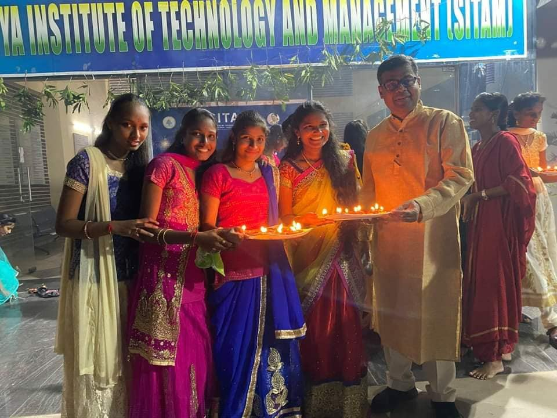

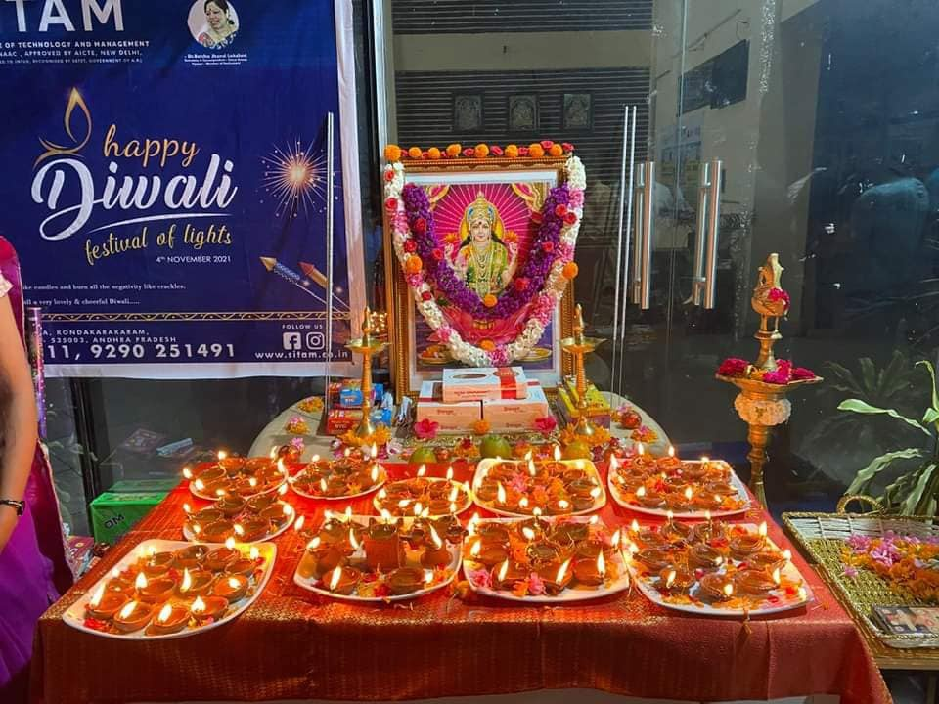

SANKARANTHI CELEBRATIONS AT SITAM COLLE
DATE:13-01-2022

Former Member of Parliament Sri Dr. Botcha Jhanshi Lakshmi wanted to celebrate Sankranti while keeping a social distance. On Thursday, SITAM Engineering College distributed new clothes on a large scale in honour of Sankranti. Although teaching and non-teaching staff in Satya educational institutions were given clothes and sweets. She handed over the gifts, demonstrating her love for those who have travelled long distances to celebrate Sankranti.

She hoped that this festival, which is celebrated on days when farmers are prosperous, would be celebrated with care so that even on Ugadi, the corona situation would improve and everyone would be happy.

Dheera Convenor Dr. Botcha Sandeep congratulated the staff in the program. Director of SITAM Majji Sashi Bhushana Rao, SITAM Principal DV Ramamurthy, Satya Degree College Principal Mrs. Sai Devamani, SITAM Vice Principals Dr. Damodar Naidu and Ch.Venkata Lakshmi, Captain Satyaveni and others were present.

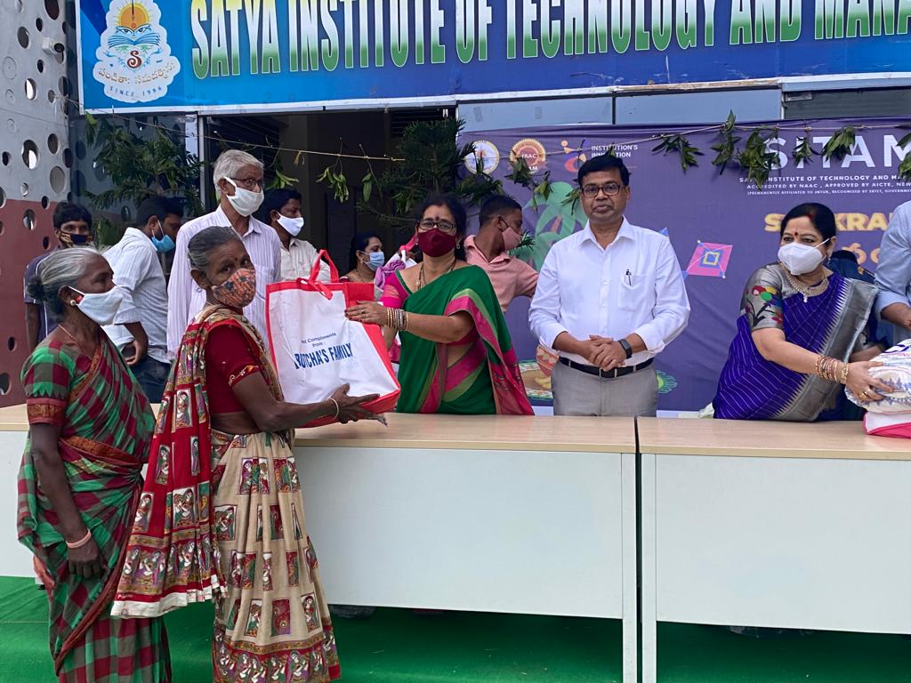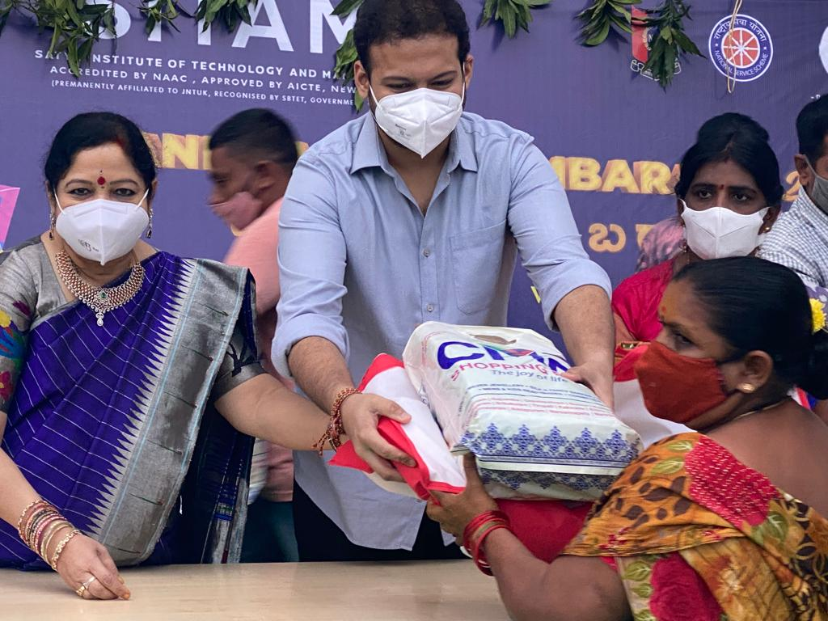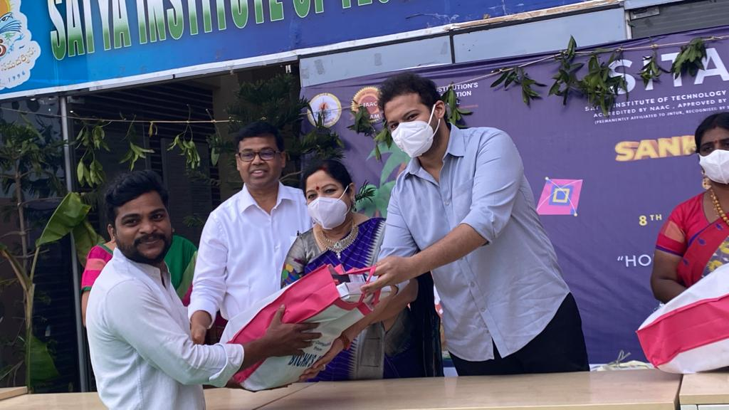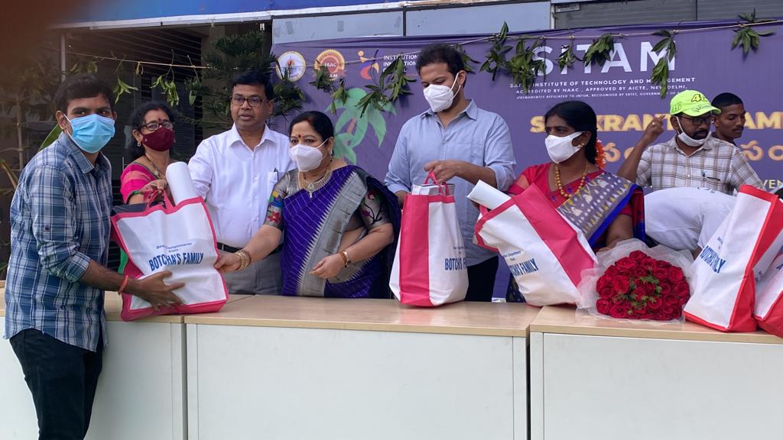

REPUBLIC DAY CELEBRATIONS AT SITAM ENGINEERING COLLEGE

DATE :26/01/2022

The 73rd Republic Day celebrations were organized by SITAM Engineering Colleges on the SITAM Engineering College campus.

The celebrations began with the college director, Mr. Majji Sashi Bhushana Rao, hoisting the flag. The parade, drill, and pyramid formations by NCC students were the main attraction on this occasion. Denkada Police Station Constable Mr. Nadukuru Ishwara Rao, Youth Foundation Founder and President Mr. Shaik Iltamush, Secretary Youth Foundation Vizianagaram and Life Spring Ambulance Service Owner Mr. Chitthuri Tirupati Rao, Garugubilli RMP for their services on the occasion of Republic Day. Mr. Majji Sashi Bhushana Rao, the director of the college honored them as recognition.

Mrs. Anuradha, Dr. T. Damodar, Vice Principal of Sitam College, Dr. M. V. Sai Devmani, Principal of Satya Degree College, NCC officers from both colleges, Captain M. Satyaveni, Lt. M. Varalakshmi, NCC Caretaker S. Prashanth, CSO Satyanarayana, teachers, and students took part in this ceremony.

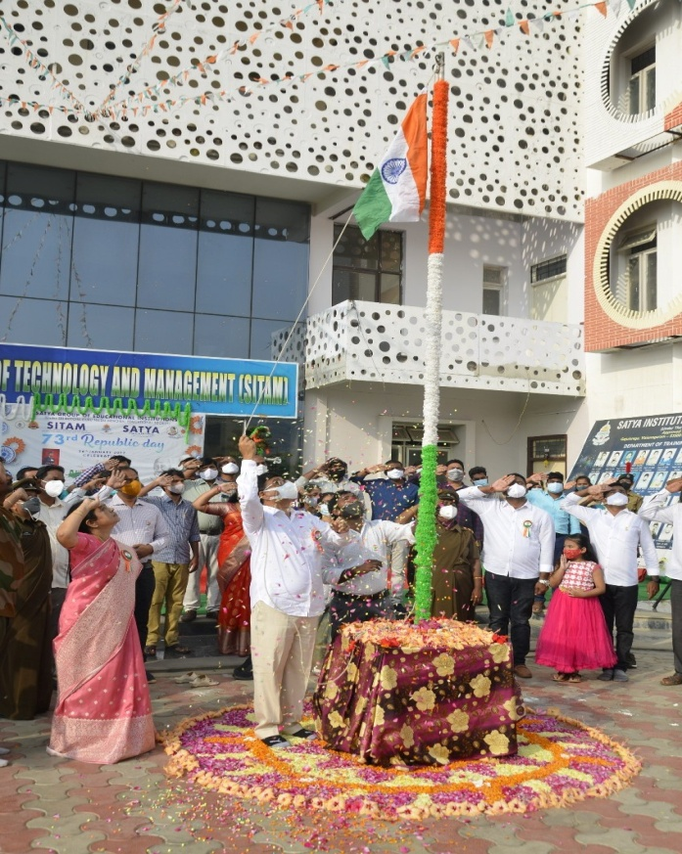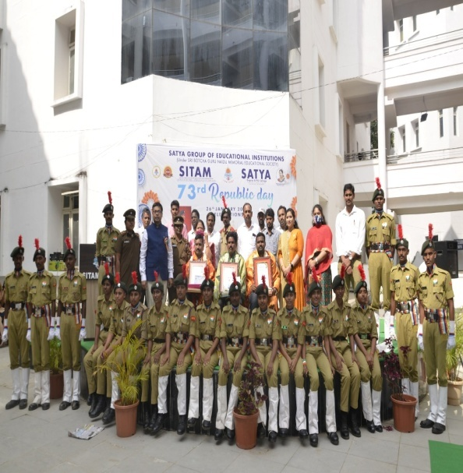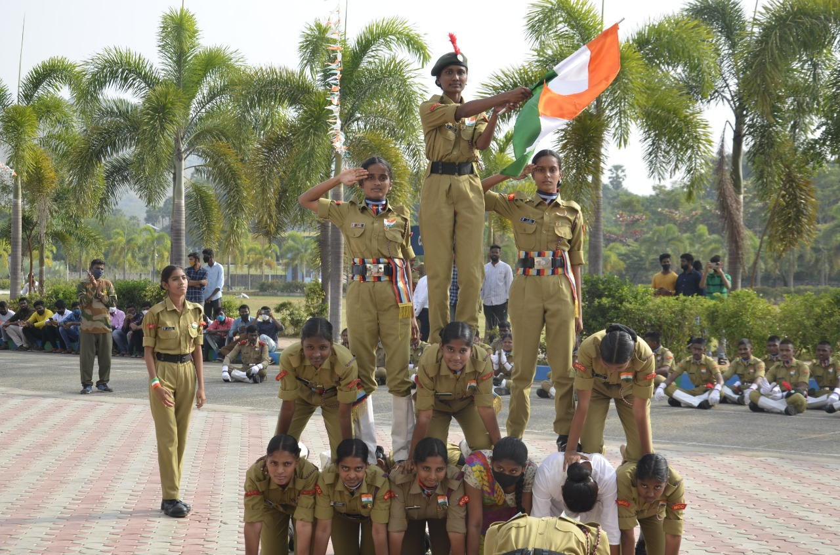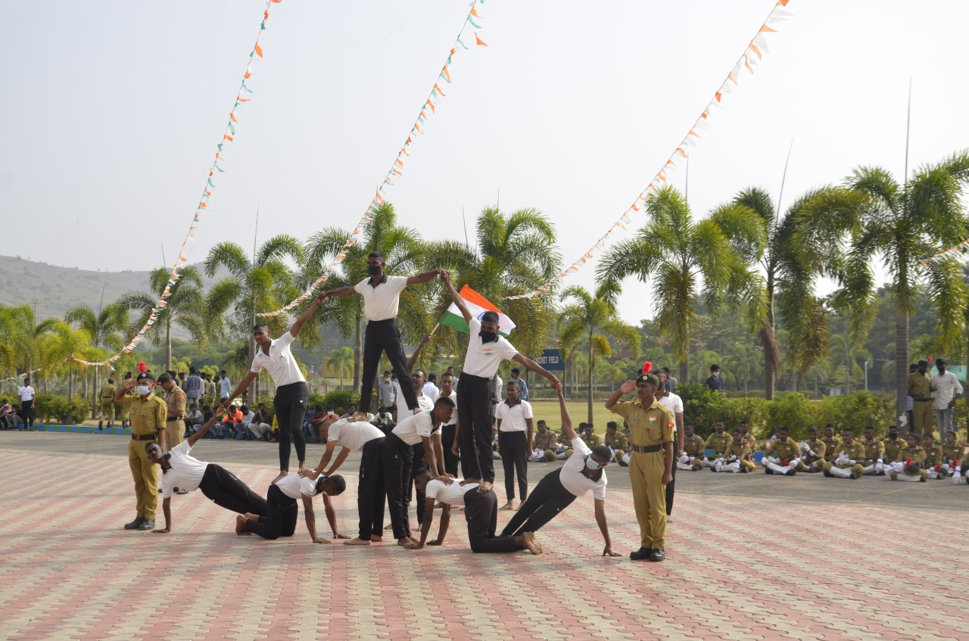

NAME OF THE EVENT: INTERNATIONAL WORLD YOGA DAY

DATE : 21/06/2022

Yoga Guru Sri. B Papa Rao emphasised the importance of yoga for good health, stating that "Om" is our bodies' oxygen. He was the featured speaker at Satya Group of Educational Institutions' International Yoga Day. Students and NCC cadets were briefed on the importance of developing "Yoga for Mankind" for mankind's physical, mental, and spiritual well-being, thereby progressing in all spheres, and practiced various yoga mudras, asanas, and breathing exercises.

On this occasion, SITAM Director Dr. Majji Sashi Bhushana Rao stated that students should leave their differences with others and avoid thinking negatively about their health.

The NCC cadets stated that the Yoga Guru Shri Papa Rao session helped them improve their memory and concentration, as well as their education.

On this occasion, Dr. Saidevamani, Principal of Satya Degree College, thanked the chief guest, Mr. Paparao garu, for inspiring students to practise yoga by organising yogasanas in a cheerful and humorous manner.

Sitam Principal Dr. DV Ramamurthy, Lt. Varalakshmi, Captain Satyaveni, Caretaker Prashant, physical education teachers and staff of both educational institutions participated in the program.

