

SATYA INSTITUTE OF TECHNOLOGY AND MANAGEMENT
SATYA INSTITUTE OF TECHNOLOGY AND MANAGEMENT
Gajularega, Vizianagaram, Andhra Pradesh, India-535002.
Accredited by "NAAC"
Approved by AICTE and Affiliated to JNTUK, KAKINADA
Email: Satya Institute of Technology and Management@Satya Institute of Technology and Management.co.in, Website:www.Satya Institute of Technology and Management.co.in
Telephone No:9676788811, 8978812341/2, Land Line: 08922-234775
IQAC- SATYA INSTITUTE OF TECHNOLOGY AND MANAGEMENT
Qualitative Metrics
Criterion 7-Institutional Values and Best Practices
7.1.6 | Quality audits on environment and energy regularly undertaken by the institution  1.Green audit  2. Energy audit  3.Environment audit  4.Clean and green campus recognitions/awards  5. Beyond the campus environmental promotional activities

OVERVIEW
SITAM has an eco-friendly environment. It has a long legacy of healthy environmental practices including periodic plantation, their preservation and maintenance. Its land use is such that about 30 % of the total area is occupied by open land and plantation that generates a better and sustainable campus environment.

INTRODUCTION TO GREEN AUDIT

A green audit is a methodical process for identifying, quantifying, logging, reporting, and analyzing different businesses' environmental diversity components. It seeks to examine environmental policies both inside and outside of SITAM that may have an effect on the environment-friendly ambiance. A green audit can be a beneficial tool for a college to identify the areas and processes where the most energy, water, and other resources are being used. In order to better waste minimization plans or start recycling projects, it can also be used to determine the type and volume of garbage. It can spread environmental awareness, ethical standards,and and a sense of and a sense of environmental responsibility.
It gives staff and students a greater knowledge of the effects of sustainability on campus.It may be said that institutional self It gives staff and students a greater knowledge of the effects of sustainability on campus.It may be said that institutionalenquiry is a natural and necessary offshoot of a quality education.The college must thus assess its own contributions to a sustainable future. The importance of higher education institutions in regard to environmental sustainability is on the rise as it becomes a national issue that affects the entire country.Numerous environmental and ecological problems have been brought on by the rapid urbanisation and economic development at the local, regional, and global levels.In light of this, it is crucial that educational institutions implement the "Green Campus" approach in order to promote sustainable growth and significantly reduce atmospheric carbon dioxide emissions.All higher education institutions must now submit an annual Green Audit Report as required by the National Assessment and Accreditation Council, New Delhi (NAAC).Additionally, it is a component of the higher education institutions' corporate social responsibility to make sure that they take steps to reduce their carbon footprint in order to combat global warming.

OBJECTIVES
The Green Audit of an institution is now of utmost importance for the institution's self-evaluation, as it represents the institution's contribution in reducing the current environmental issues. Since its founding, the college has made attempts to maintain a clean campus. The current green audit's goal is to identify, quantify, characterise, and prioritise the environmental sustainability framework in accordance with the laws, policies, and standards that are relevant.
The main objectives of carrying out Green Audit are:
1. Layout plan of the college
2. Improving environmental standards
3. Reduction and reuse of resources available
4. Financial savings through a reduction in resource use
5. Environmental education through Curriculum
6. Enhancement of college profile
7. Developing environmental ethics and value systems in young minds.

Table 1: Audit Participants
Name | Designation/ Department
Dr. G.RAVI KISHORE | Dept of CIVIL Engg, SITAM
Dr S Varudhini | Dept of MBA, SITAM
Ramu

METHODOLOGY
The goal of SITAM College's green audit is to make sure that the campus's practices adhere to the green policy that the college has adopted. The process consists of a visual assessment of the campus, documentation study and observation, key person interviews, measurements, and recommendations.

FINDINGS OF GREEN AUDITING
The college has adopted the ‘Green Campus’ system for environmental conservation and sustainability. Green audit concentrating on three major points : having a zero environmental footprint, having a positive impact on occupant health and performance, and having 100% of graduates demonstrate environmental literacy. The goal is to reduce CO₂ emissions, energy and water consumption, and also creating an environment in which students can learn and be healthy.

OBSERVATIONS

- Layout Plan, SITAM

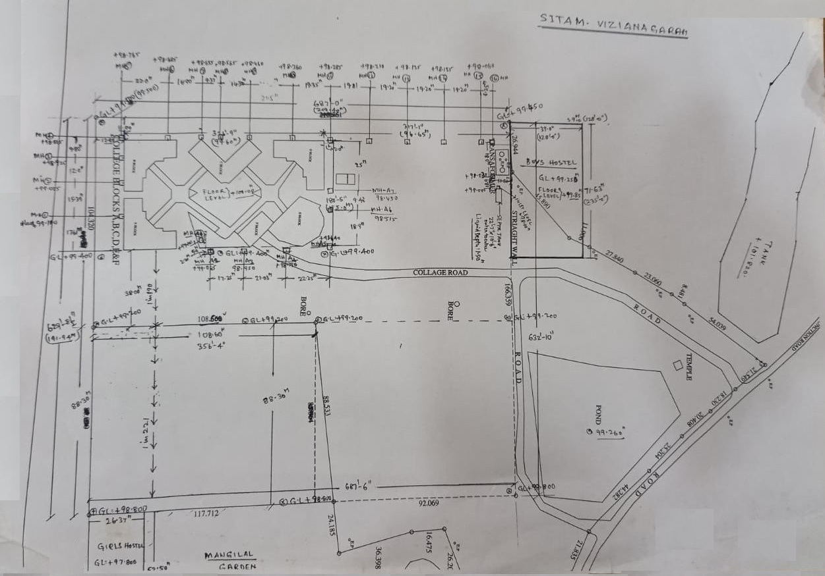

ii. land used data of Satya Institute of Technology and Management, Vizianagaram – 535002
Table 2
CATEGORIES OF LAND USE | USE AREA (ACRES)
BUILDING AREA | 3.62
GROUNDS | 2.81
SHEDS | 0.392
BOYS HOSTEL | 0.36
GIRLS HOSTEL | 0.18
CANTEEN | 0.042
LAWNS/BIG TREES/SHRUBS | 2.308
WALKWAYS | 1.938
TOTAL AREA | 11.65

TREE DIVERSITY

The region is quite diverse, with numerous tree species serving a number of purposes. The majority of these tree species were introduced into the campus throughout a variety of time periods through various plantation programmes arranged by the authority. The college's trees have improved the quality of life for everyone in the area, benefiting not only the college community but also the general public by improving air quality, preserving soil, conserving water, reducing climate change, and regulating the climate by reducing the effects of the sun, rain, and wind. The radiant energy of the sun is absorbed and filtered by leaves, keeping things cool in the summer. These trees provide refuge and food for a variety of animals. Birds and numerous insects both devour flowers and fruits. Numerous creatures, including birds and squirrels, are protected from predators by the leaf-covered branches. Numerous species exhibit an almost infinite range of shapes, forms, textures, and vivid colours. Even individual trees alter in appearance as the seasons change throughout the year. The durability, longevity, and regal grandeur of trees give them the appearance of monuments. They also serve as a reminder of our institution's illustrious past. These trees frequently strike an emotional chord with us, and occasionally we develop a close relationship with the ones we pass every day. A thick belt of large shady trees in the periphery of the college have found to be bringing down noise and cut down dust and storms. Thus, the college has been playing a significant role in maintaining the environment of the entire campus and its surrounding areas.
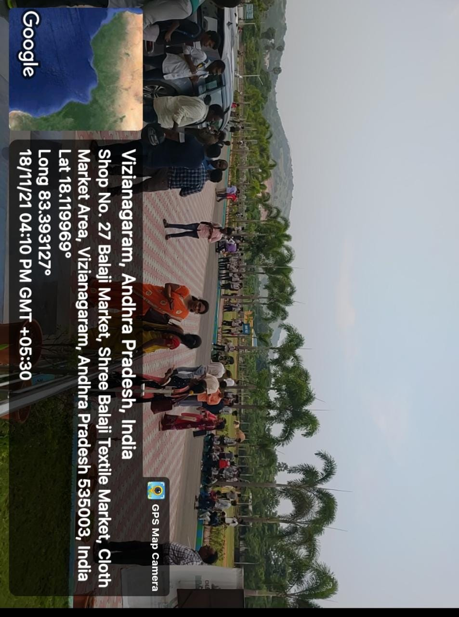
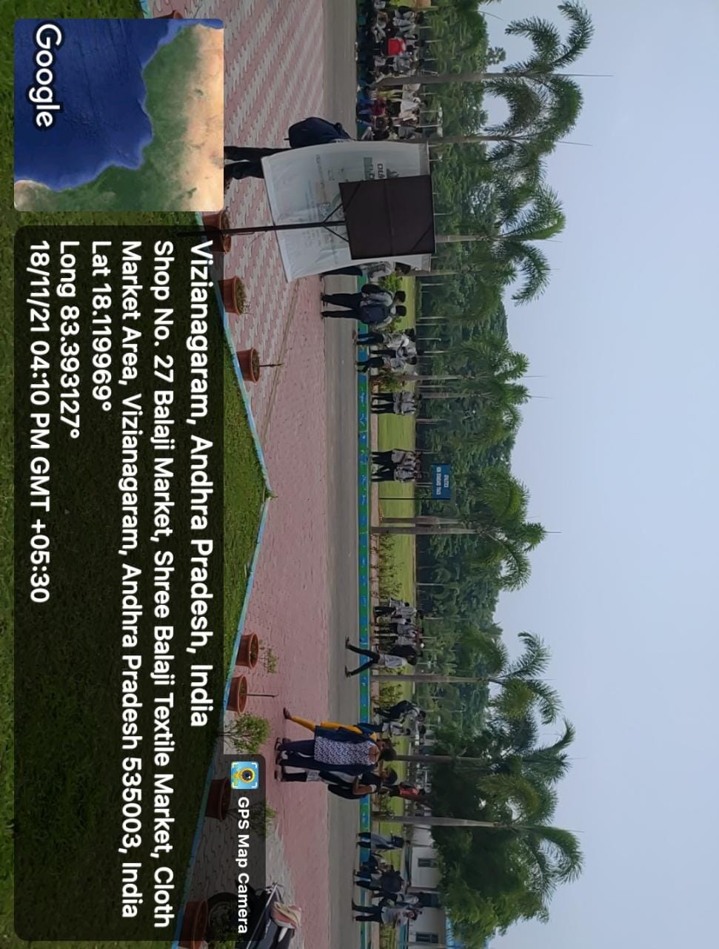
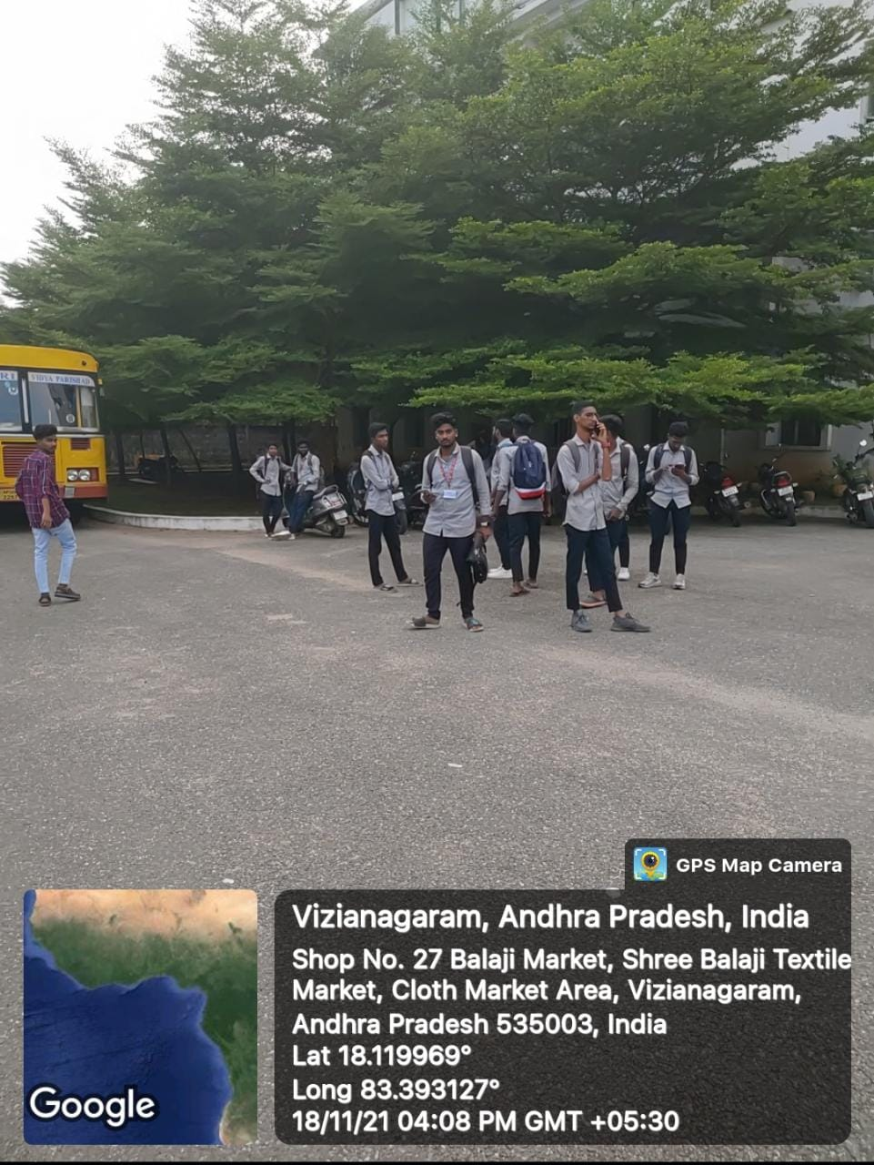

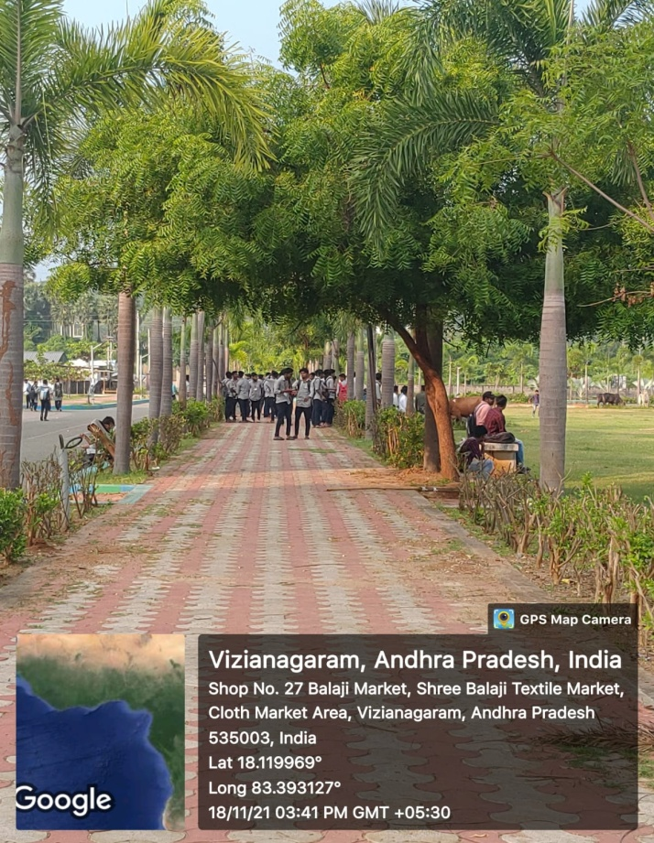
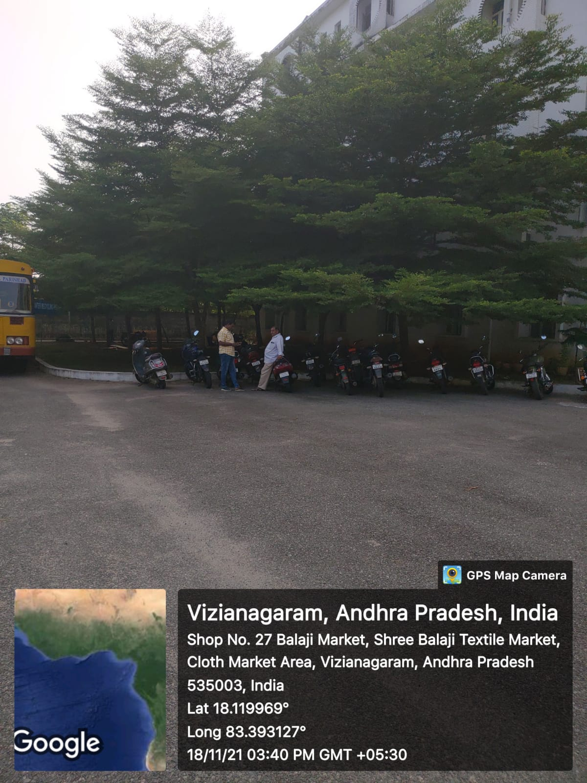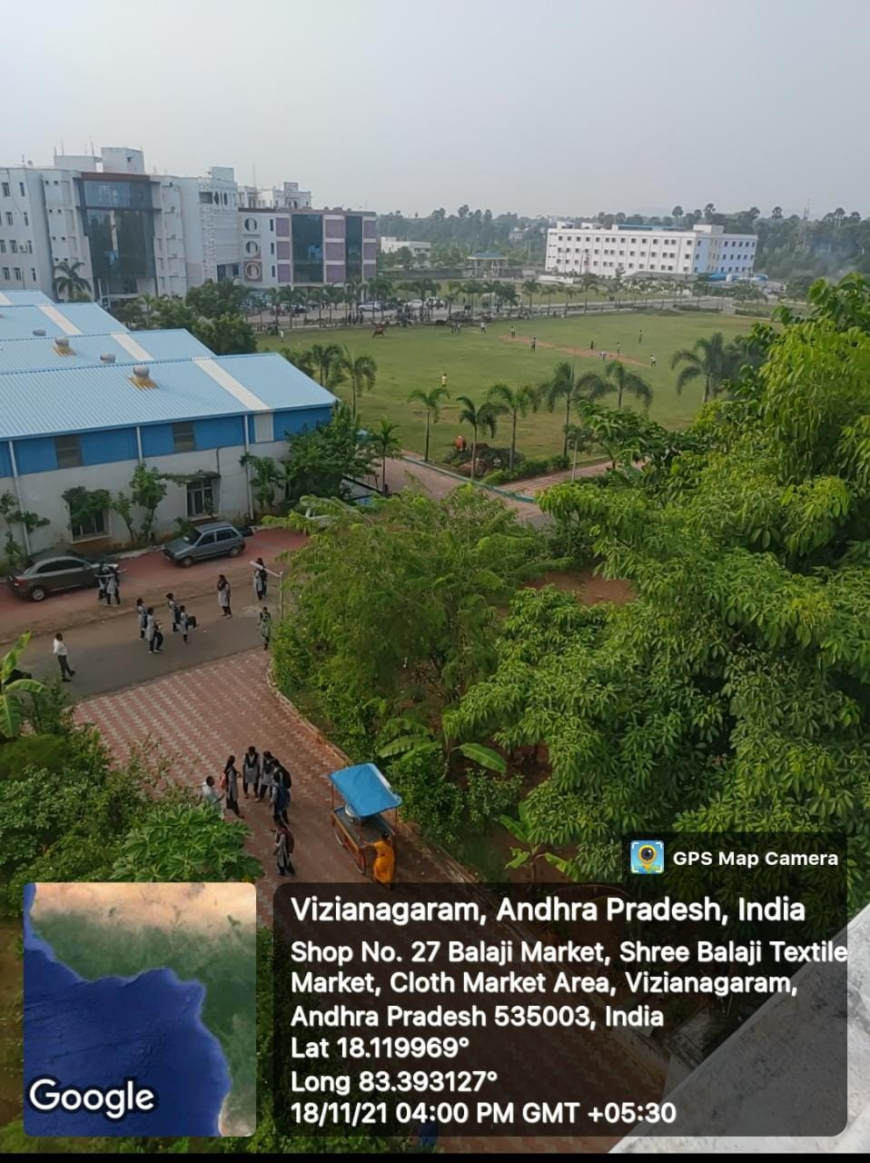

WATER AUDIT
- Facilities of raw water intake through bore wells and municipal water supply.
- Facility for waste water treatment through Sewage Treatment Plant (STP), recycled water utilized for lawns and plantations within the campus.
- Rain water Harvesting (RWH) facility is provided to the girl’s hostel which is located inside the campus.

WATER ANALYSIS REPORT
Table 4
Parameter/  WHO Permissible Level | Observed Value |  | Methodology
 | Sample 1 | Sample 2
Colour | Clear | Clear
pH / 6.5-6.8 | 6.8 | 6.85 | pH meter
Turbidity/ 5-10NTU | 3 | 4 | Turbidity meter
Conductance / (2500 us/cm | 1500 | 1489 | Conductivity meter
Fe /0.30 ppm | 0.2 | 0.2 | By radix titration
Na/200 ppm | 180 | 180 | spectrophotometer
K/ 55 ppm | 55 | 55 | spectrophotometer
Mg/ 30 ppm | 100 | 112 | EDTA titration
Ca/ 75 ppm | 80 | 90 | EDTA titration

NOISE LEVEL in campus, Vizianagaram
- Majority of the students comes from local city, are advised to utilize the college bus facilities.
- If students are using their own vehicles are strictly advised to minimize the speed limit and not to horn inside the campus.
- Also students are advised to not to use vehicles unnecessarily within the campus to minimize the air pollution.
- Even though Orissa highway runs beside the campus, no noise pollution harms the learning environment, as the buildings are nearly about 500mts away from the road and also the tall trees inside the campus acts as obstrucals for noise transmission.

WASTE DISPOSAL AUDIT
Waste Management assists institutions in enhancing their environmental performance with clever programmes like our Think Green Campus Model. Reusing or recycling helps us: save natural resources, save energy, safeguard the environment, and decrease landfill usage. By decreasing the carbon emissions linked to both getting rid of old things and buying new ones, we will lessen our influence on the environment. SIATM adopts environmentally responsible practises and takes the required steps, including carbon neutrality, waste recycling, and energy saving. The other solid trash produced on campus is transferred to the community bin for recycling and disposal, while the biological recyclable waste is processed into organic manure for the campus plants.
Disposable Audit
Table 5
Type of Waste | Disposal Method |  | Remarks
E-waste  Quantity:450Kgs  Monitor – 270 kgs  Desktop – 120 kgs  Mouse+keyboard-60 kgs | Collected in separate bin/ stores |  | Collected by Green Waves Environmental Solutions
(i) Bio-degradable  a. Organic Waste | Mass collection of organic waste will be dumped into the composed pit |  | Decomposed organic matter will be used asmanure to the plants in the campus.
b. Inorganic waste  Chemicals, glass | Earthen pits |  | Precautions have been taken while disposing
c. Domestic waste | Cattle feeding |  | Collected from Hostels, Canteen.
d. Electrical waste  Tube lights, bulbs, wires, electrical stoves | Collected in separate bins
e. News Papers, waste papers, blue books | Sold for recycling |  | Collected by local municipal authorities.
f. Metal scraps Steel | Sold for recycling |  | Collected by local municipal authorities.
g. Timbers Furniture scraps | Store room
h. Resins Fuel, oil, Greece | Earthren pits
(ii) Non-Bio- degradable  a. Sanitary Waste | Incinerator |  | Provided to ladies hostel
b. Plastic Waste | Dust bins |  | Collected by municipal authorities.
(iii) Scrap equipments | Stores |  | Collectively sold in amass
(iv) Constructional waste Concrete, Bitumen | Dumping in a specific place in the laboratory |  | Used for land filling  within the campus
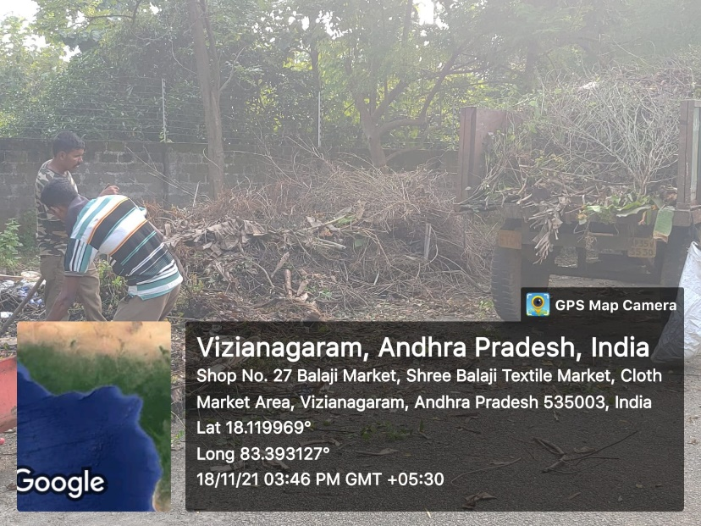 |  | 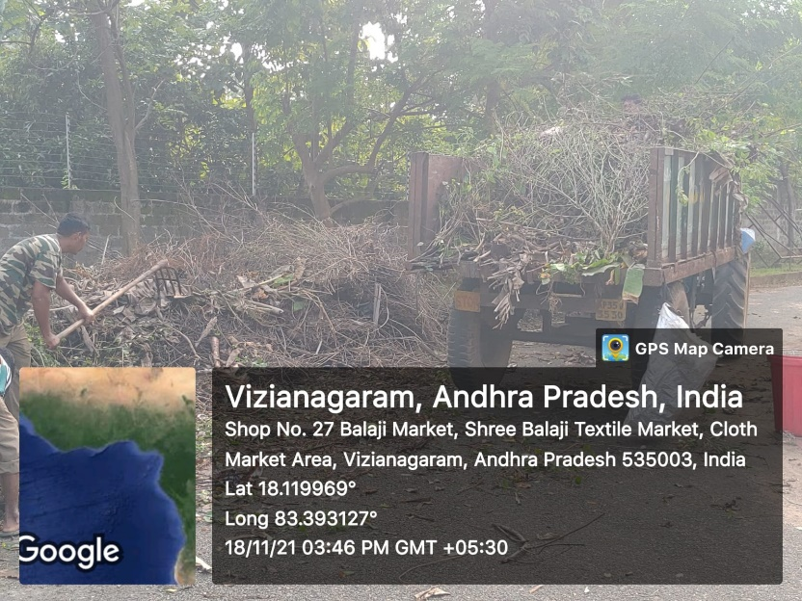
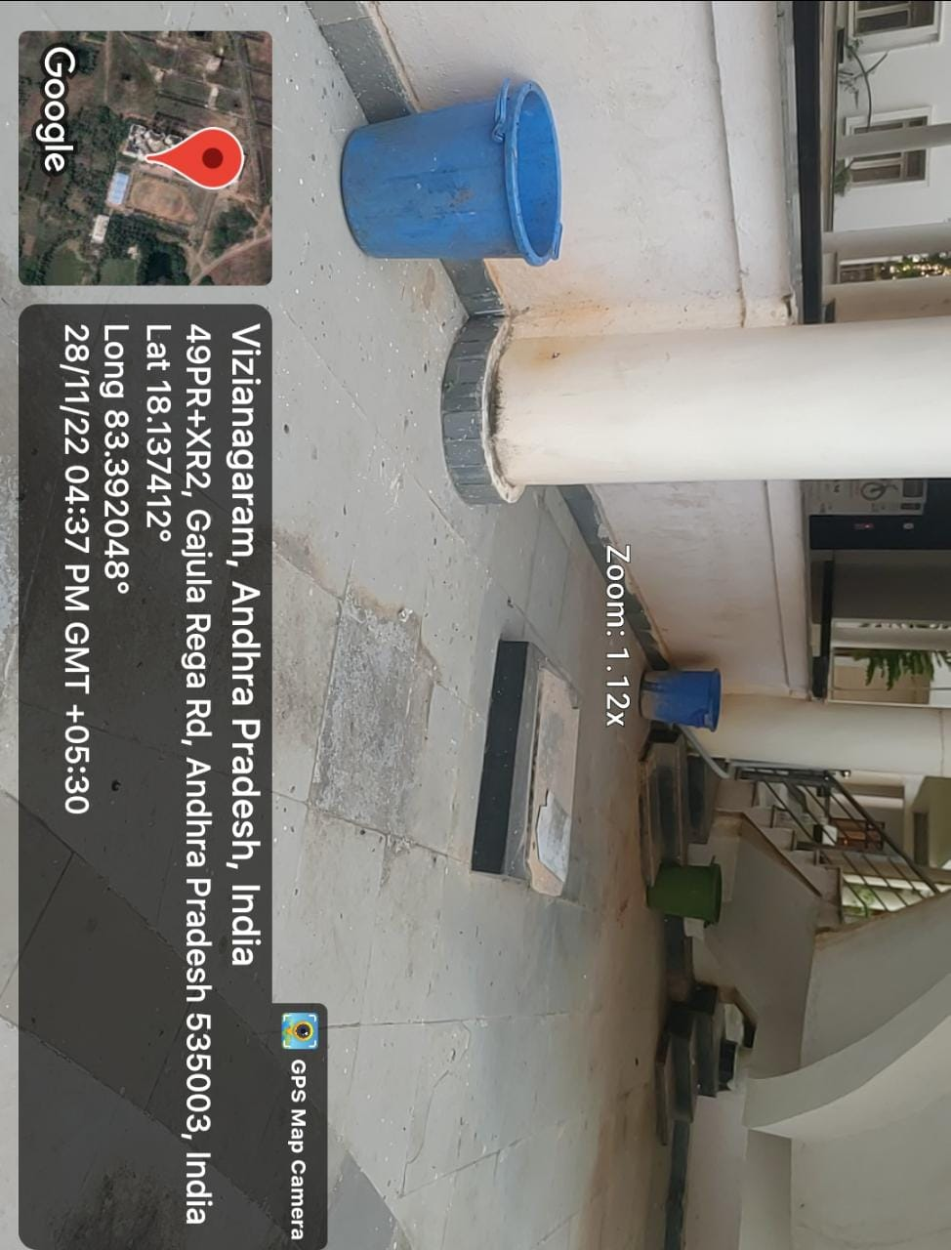
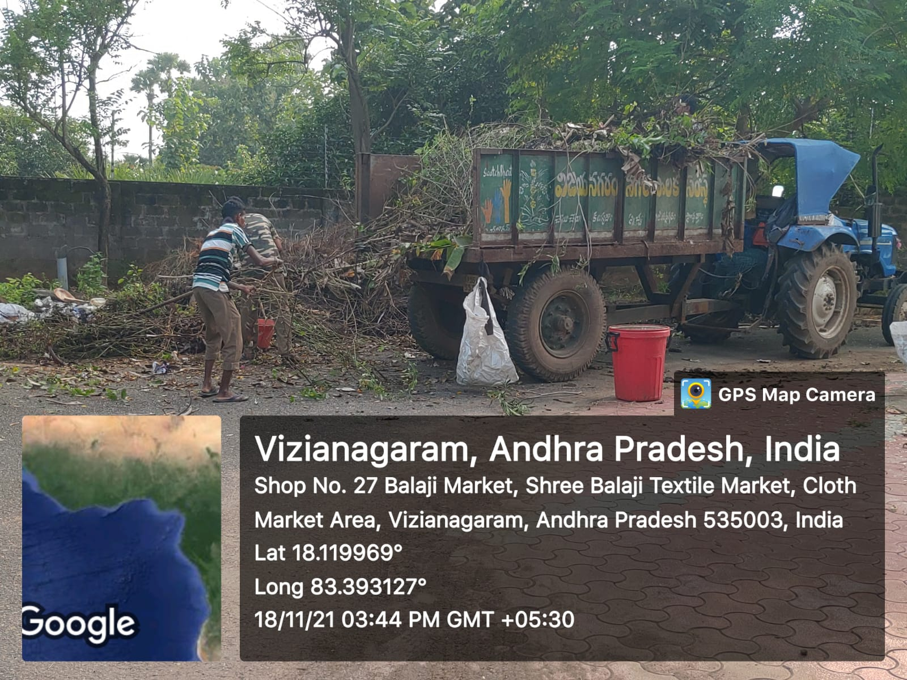

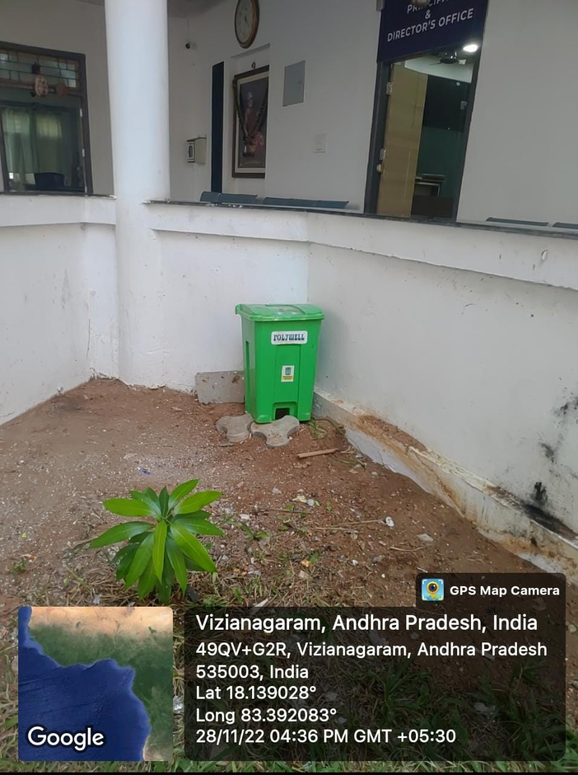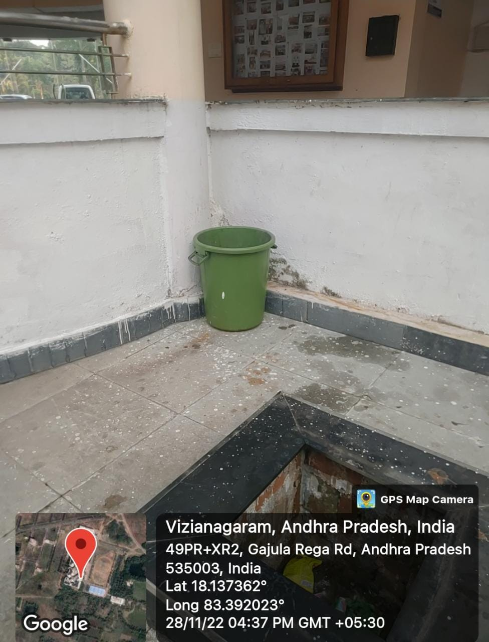

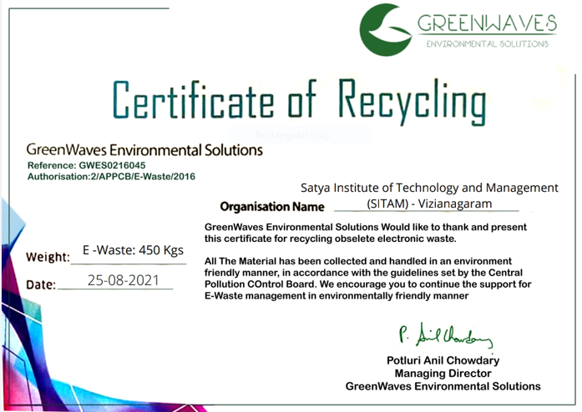

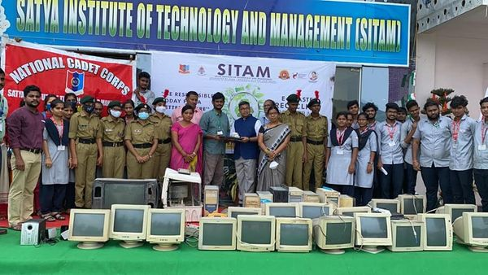

ENIVRONMENTAL QUALITY AUDIT
- Programs have been undertaken by the institute for plantation. The green belt is also maintained to reduce the pollution level by decreasing the carbon dioxide level.
- Every year on June 5th World Environmental Day (WED) will be celebrating by inviting a special guest to elaborate impact of healthy environment on human life among students and staffs.
- As a part of curriculum, university has incorporated environmental related subjects to have environmental education.
- Generated Solid wastes like waste papers, Blue books, vegetable matter and miscellaneous are systematically dumped into a earthen pit for natural decomposition instead of burning, thereby reduction in CO₂ has achieved.
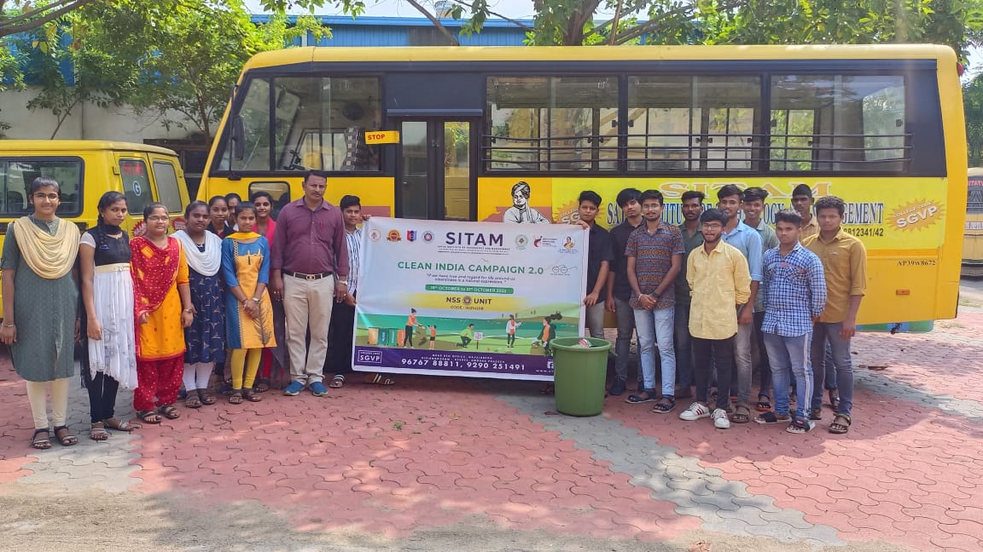
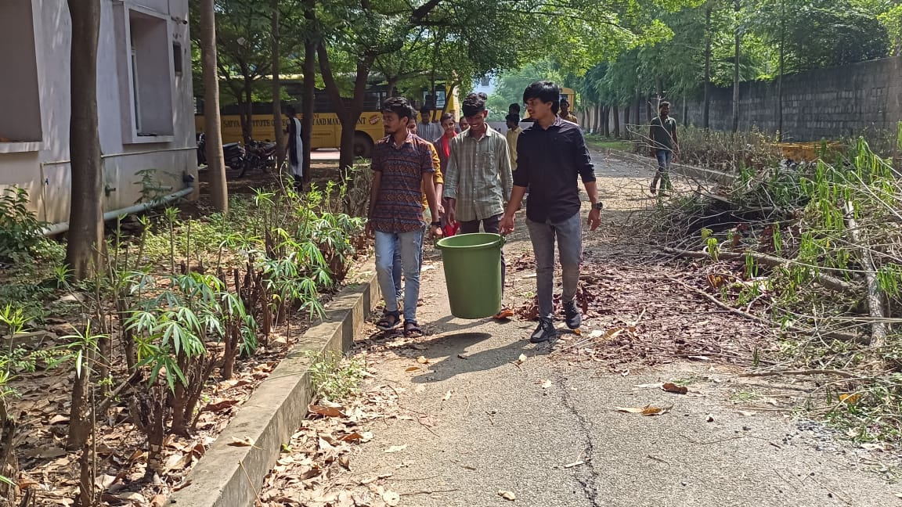
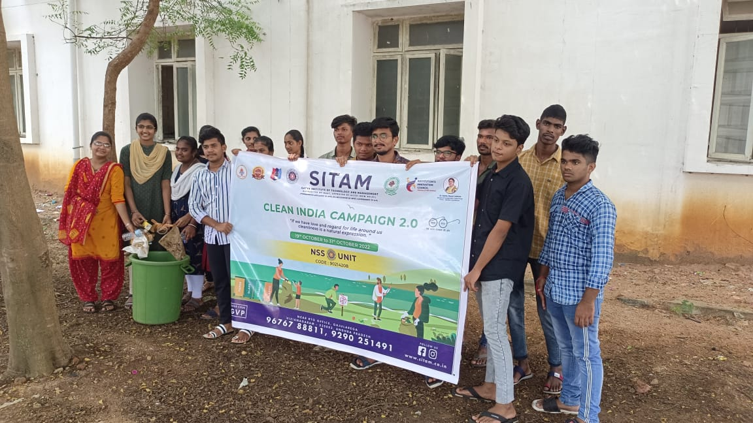

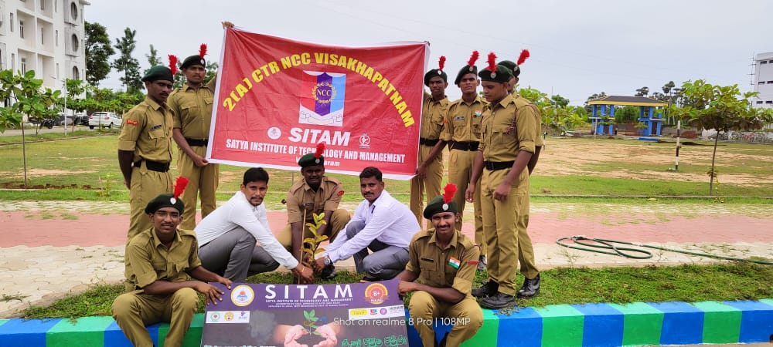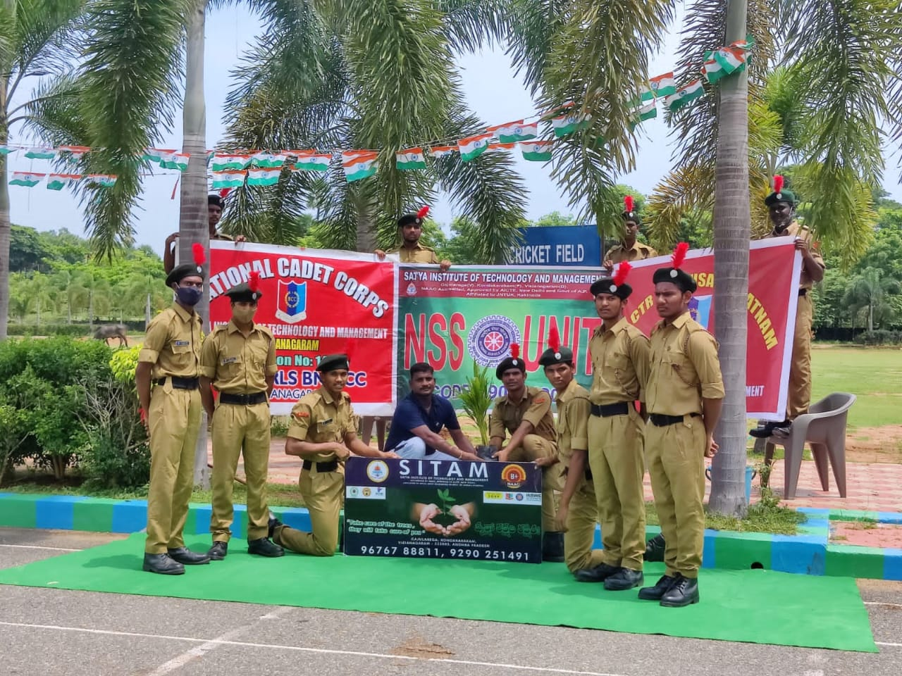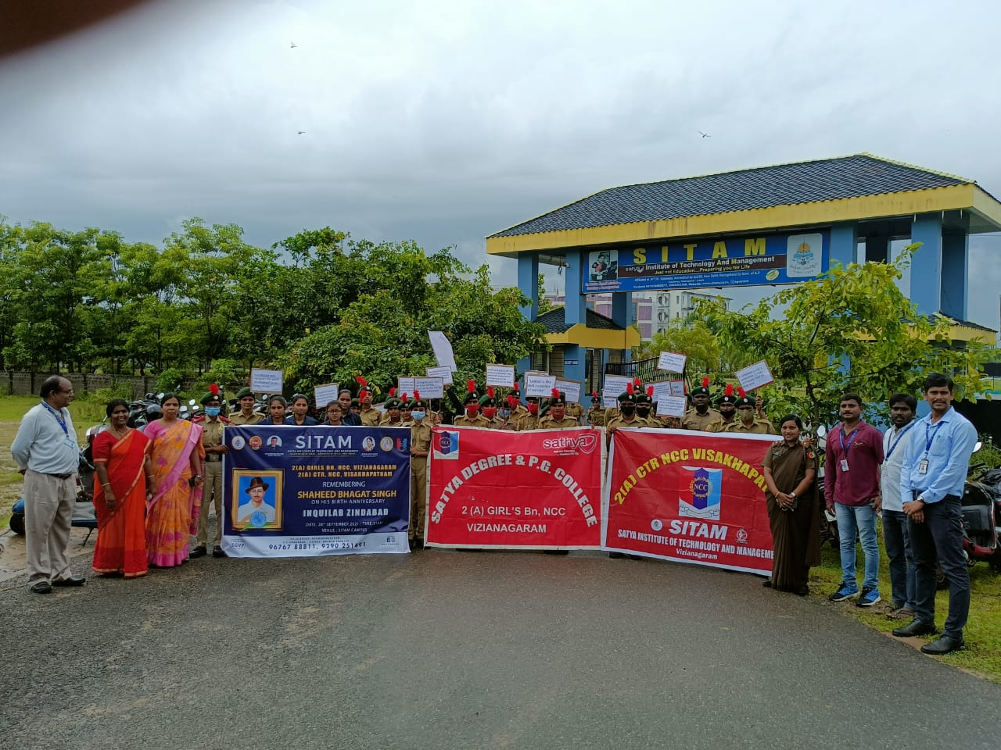
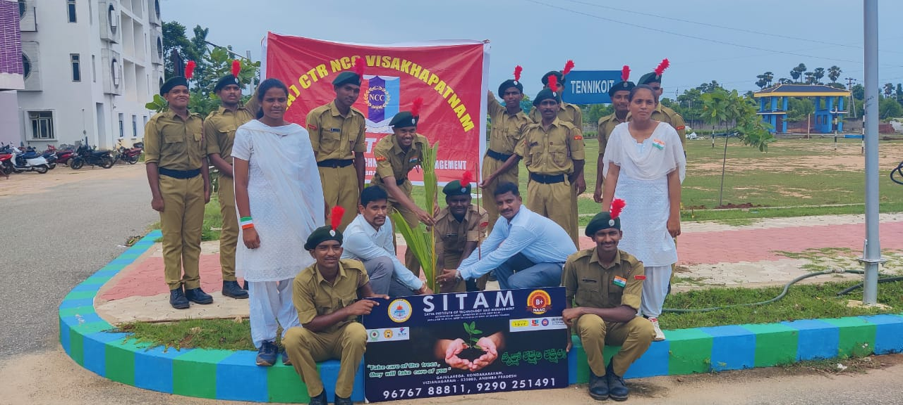

HEALTH AUDIT
- Every semester students are advised to undergo one health check up facility provided inside the campus.
- Blood donation camp also been conduct every year by NSS and by individual departments.
- Yoga also been conduct every year on 21 June.

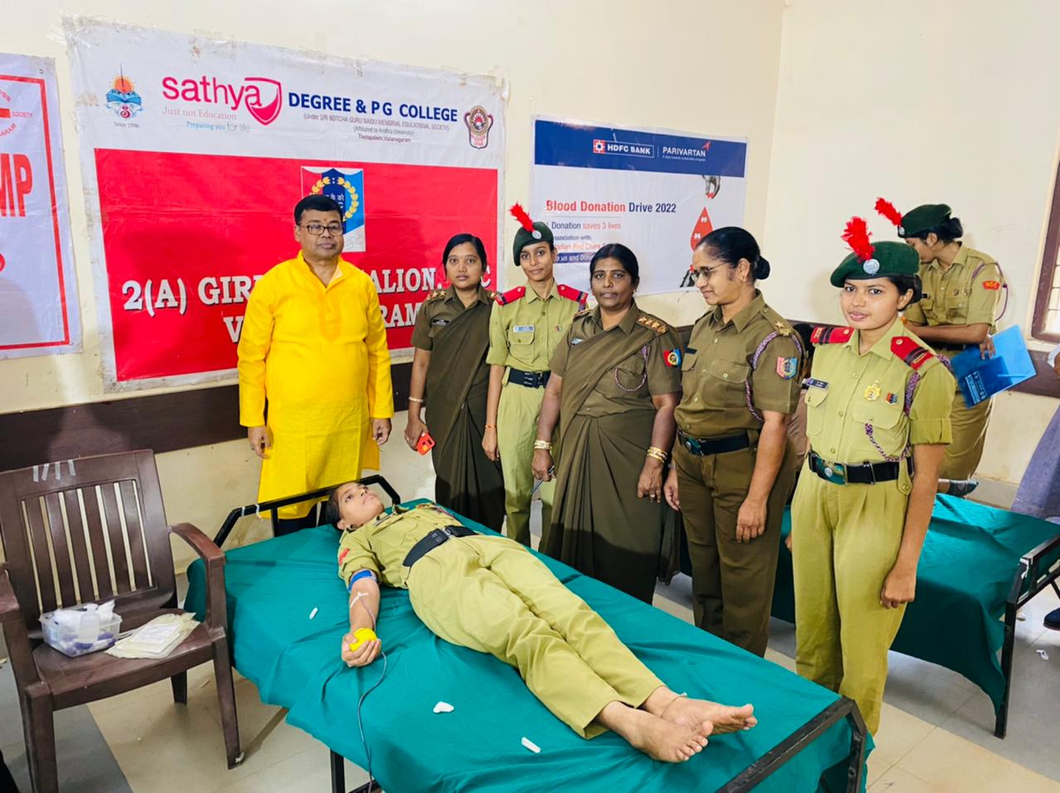
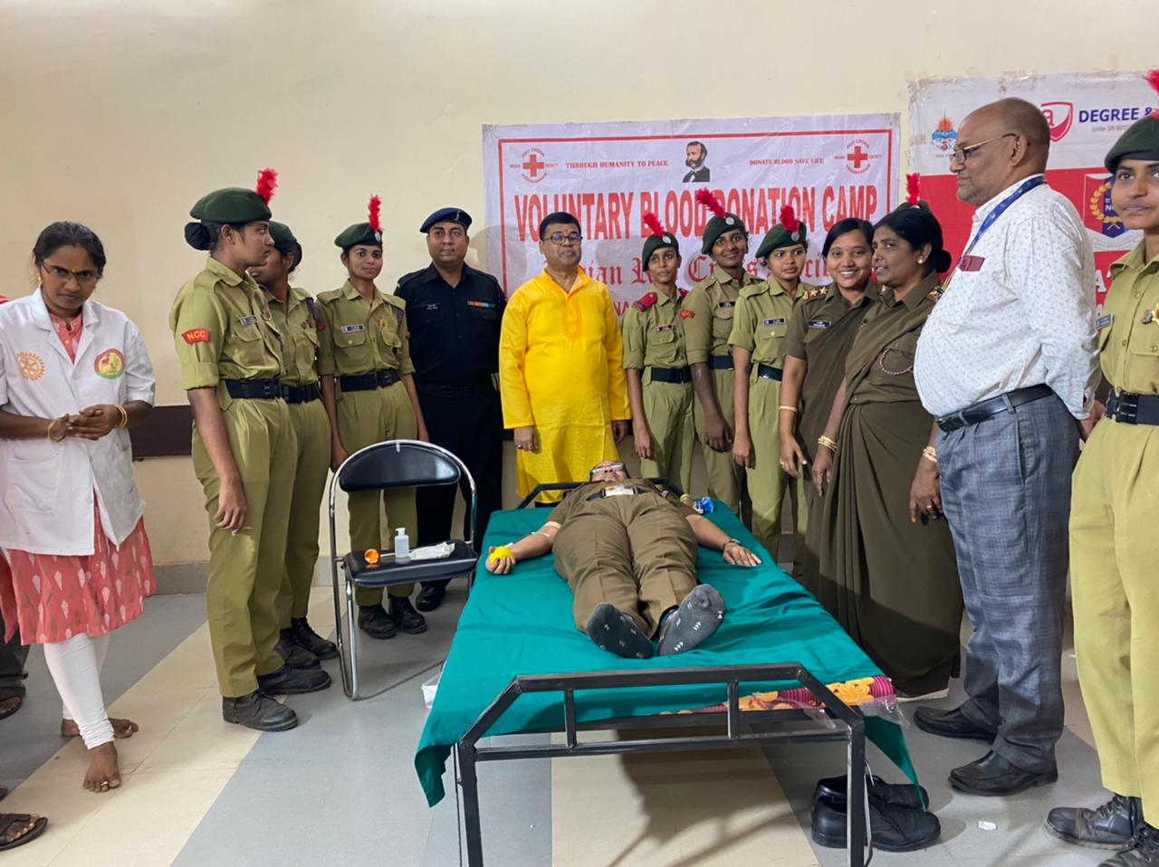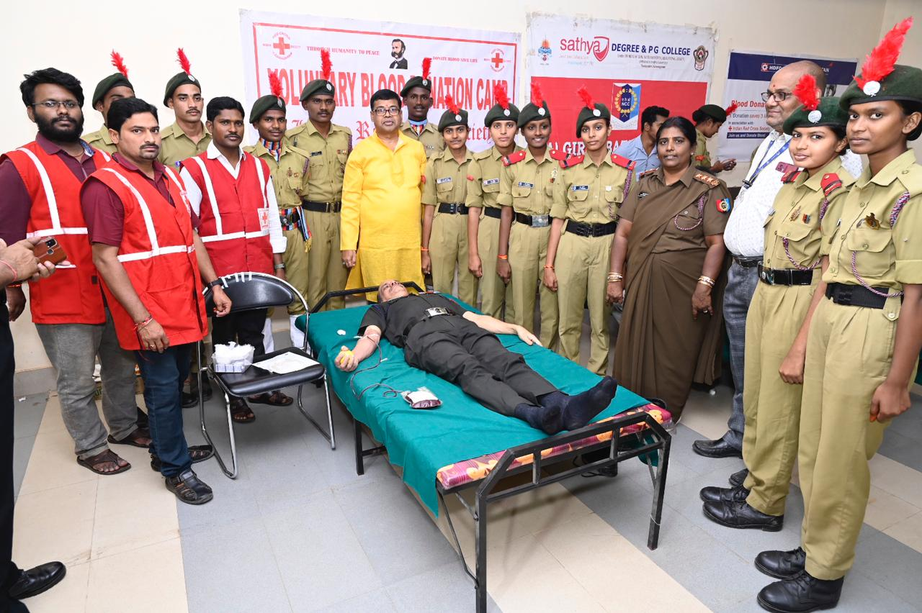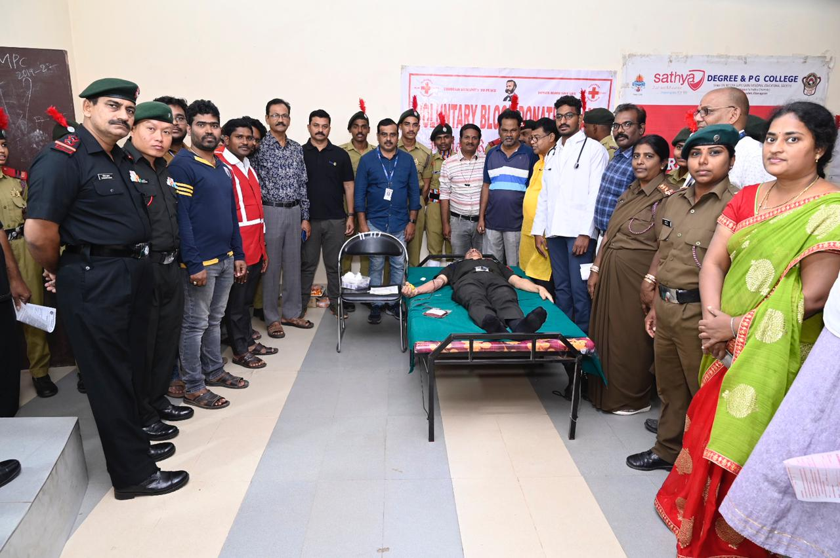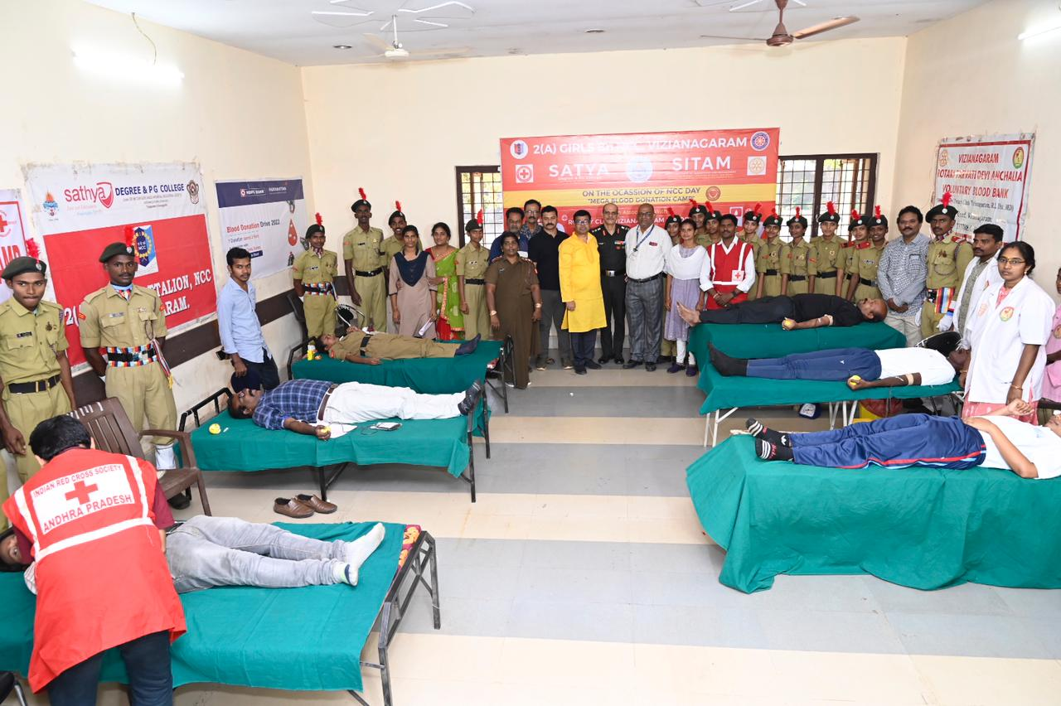


RENEWABLE ENERGY AUDIT
- All buildings on campus have solar panels installed for power generation and hot water facilities.
- The campus's girl's hostel has access to a rainwater harvesting (RWH) system.
- Solar energy generated on the college campus is transferred to the community trash can for recycling and disposal.
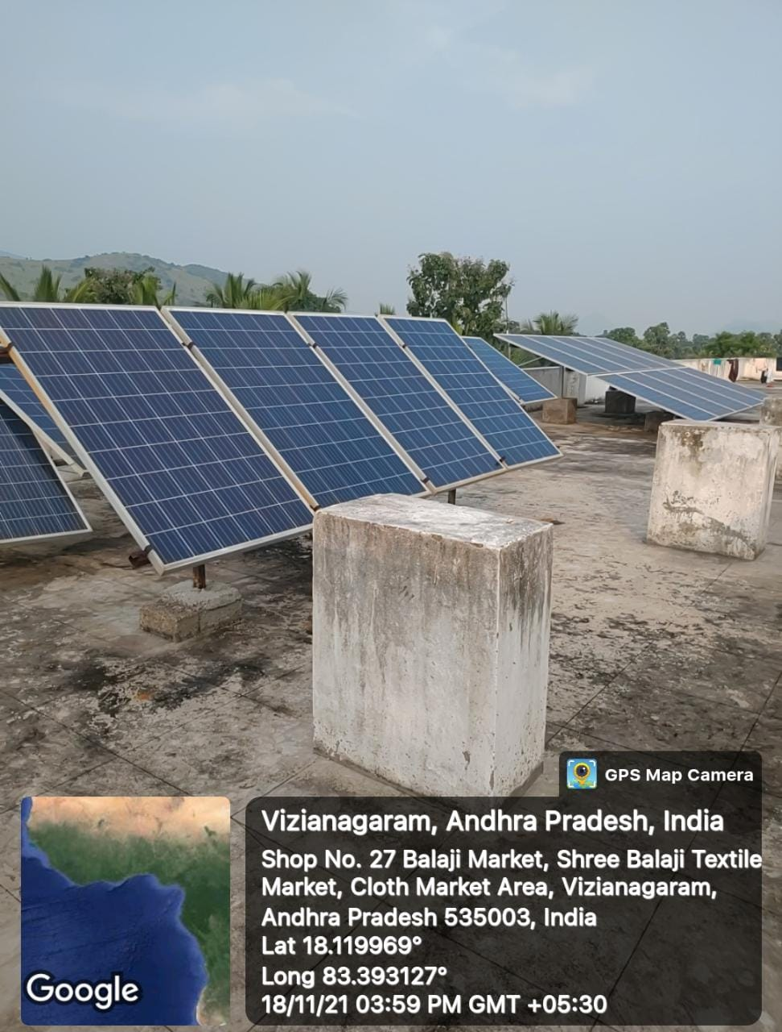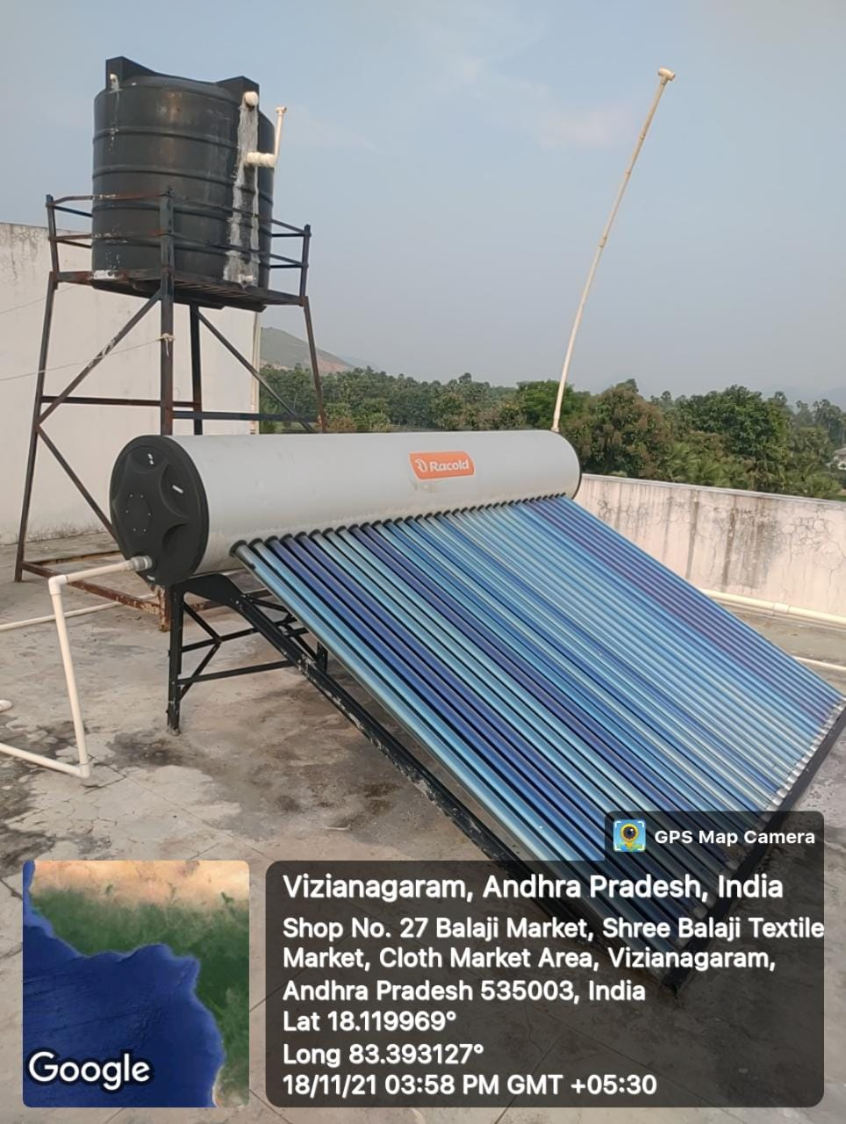

Energy Audit Report
Introduction:
A country is working to improve education for the common people of India in both quantity and quality in order to increase their intelligence. Before India gained its independence, a small group of persons controlled the whole field of education and other intellectual pursuits. But today, we are making quick progress in the direction of the coveted position of a developed country. But the advancement need to be steady. Energy management is crucial for accomplishing such an endless development. Regarding the current electricity issue, we experience blackouts while working in the office. Therefore, institutional management is considering power production and energy conservation from an eco-social perspective. India's energy needs are increasing, and its domestic fossil fuel reserves are insufficient. The nation has an ambitious strategy to increase its renewable energy resources, as well as a program to build nuclear power facilities. India boosts the use of nuclear energy from 4.2% to 9% of its electrical energy development facilities. 35% of India's electrical power needs were met by industrial demand, 28% by domestic household usage, 21% by agriculture, 9% by commercial use, and the remainder was met by public lighting and other ad hoc uses. Energy conservation refers to lowering energy use without compromising on quantity or quality. Energy conservation is the first step in a good energy management programme; it will result in proper equipment rating, the use of high efficiency equipment, and a change in practises that result in significant energy waste. By observing all of these, you can examine the severe electrical shortage and demand. Planning is required in order to meet one's own electrical needs. An audit of college electricity usage has been conducted for this study. Fans, air conditioners, computers, and other equipment from a practical laboratory are taken into consideration in this study. We examined the overall college budget and the overall economic investment in power.

Energy Audit

A crew collected data for the Satya Institute of Technology and Management in Vizianagaram's energy audit. The convenience to advance the campus's energy competence was not the focus of this audit. Recognizing the mainly energy-efficient appliances was necessary for this audit. Additionally, some daily procedures involving popular appliances have been developed to help reduce energy consumption. The crew finished the energy audit survey. all information gathered from every room, lab, and classroom. The work is finished by taking into account the quantity of tube lights, fans, air conditioners, electrical devices, etc. in each room. how much each component contributed to overall electricity consumption It is installed with capacitors of the appropriate size to lessen the negative effects of inductive load.

Total Power Requirement of various Equipment

Appliance | Number of appliances | Power use (Watt) | Total Power Consume in '6' hours(watt x hours x no/ 1000) | Consumption in month  (KWh)
Tube Lights | 225 | 40 | 54 | 1296
LED Lights | 170 | 20 | 20.4 | 489.6
Ceiling Fans | 320 | 60 | 115.2 | 2764.8
Air Conditioners | 15 | 1000 | 90 | 2160
UPS | 12 | 900 | 64.8 | 155.2
Exhausted Fans | 18 | 55 | 5.94 | 142.56
Motors | 5 | 1000 | 30 | 720
Street Lights | 55 | 20 | 6.6 | 158.4
Printers | 10 | 50 | 3.0 | 72
Xerox | 2 | 1350 | 16.2 | 388.8
LCD Projector | 11 | 350 | 23.1 | 554.4
Computers | 25 | 300 | 45 | 1080
TOTAL(kwh/month) |  |  |  | 9981.76

The total energy utilization of the college for different purposes is approximately 9981.76 kwh/month.

