

SITAM
SATYA INSTITUTE OF TECHNOLOGY AND MANAGEMENT
Gajularega, Vizianagaram, Andhra Pradesh, India-535002.
Accredited by "NAAC"
Approved by AICTE and Affiliated to JNTUK, KAKINADA
Email: sitam@sitam.co.in, Website:www.sitam.co.in
Telephone No:9676788811, 8978812341/2, Land Line: 08922-234775

IQAC- SATYA INSTITUTE OF TECHNOLOGY AND MANAGEMENT
Qualitative Metrics
Criterion 7-Institutional Values and Best Practices
Key Indicator 7.1 Institutional Values and Social Responsibilities

7.1.4 | Water conservation facilities available in the Institution:  1.Rain water harvesting structures and utilization in the campus.  2.Bore well /Open well recharge  3. Construction of tanks and bunds  4. Waste water recycling  5. Maintenance of water bodies and distribution system in the campus

1.Rainwater harvesting structures and their use on campus are one of the things listed under this area that are present in SITAM, Vizianagaram.

The institute has successfully put into practice a rainwater harvesting model to maximize groundwater recharge. Rainwater is collected, channeled, and directed to raise the level of the groundwater. In order to maximize surface runoff into ground water recharge, the entire campus is set out in three levels, taking advantage of the sloping landscape. Terrace runoff is transferred to bore wells via a piping system and filtering. Through the use of a sand filter, surface rainwater is collected and pumped into a well. A sizable pit was dug at the rear of the boys’ dormitory to refuel all of the bore wells there. There is absolutely no rainwater flow on the grounds of our college or hostel.
The entire campus has adopted the rain water gathering technology, and it includes the following actions:
a) Rooftop Rainwater Harvesting: This entails collecting rainwater from the roofs of college buildings. The system put into place is as follows:
Rainwater collection from rooftops; conveyance of rainwater through water pipes, drains, or down take pipes; initial flush and filter using mesh to prevent floating debris, silt, leaves, or other organic matter; filtering through brick masonry loaded with pebbles, gravel, and sand storage;
b) Open Space Rainwater Harvesting: To ensure that rainwater percolates into the ground rather than flowing away from the surface, rainwater is recharged through various types of structures.
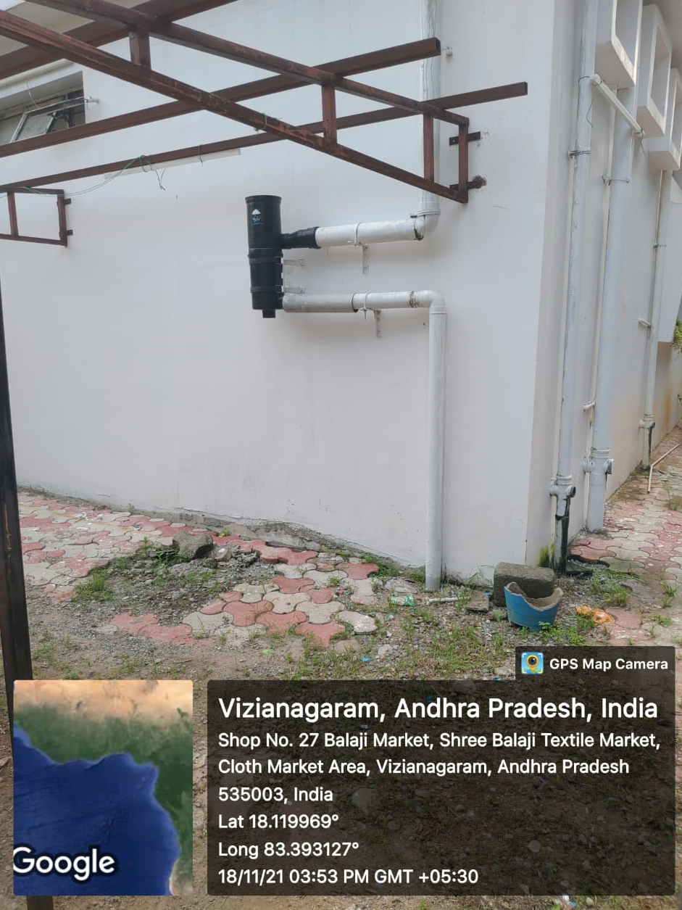

2. REPLENISHMENT OF BORE WELLS
Surface water runoff is collected through percolation to the college ground water storage tank. Additionally, this speeds up rainwater's percolation into the adjoining bore-well and underground current is also replenished. We obtained the findings below.
- Aquifer conditions on campus have improved groundwater quality, and the level of groundwater has stabilised.

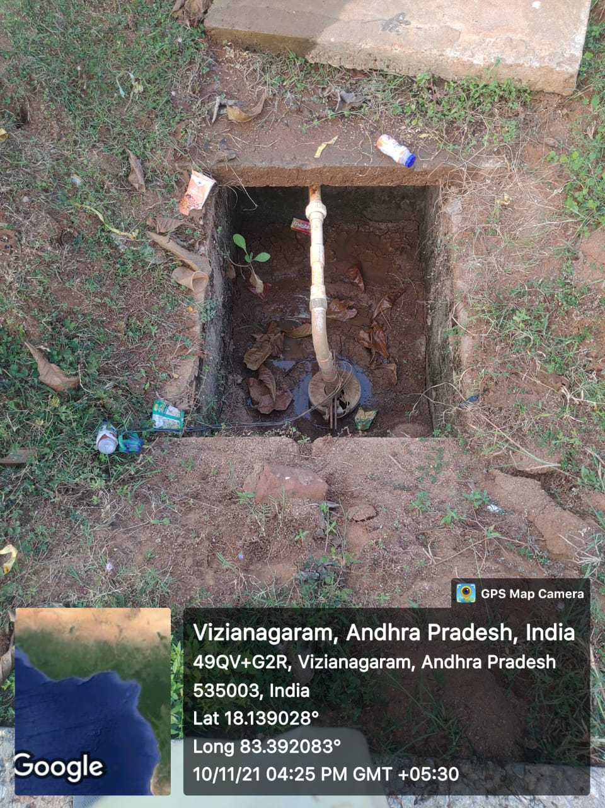 | 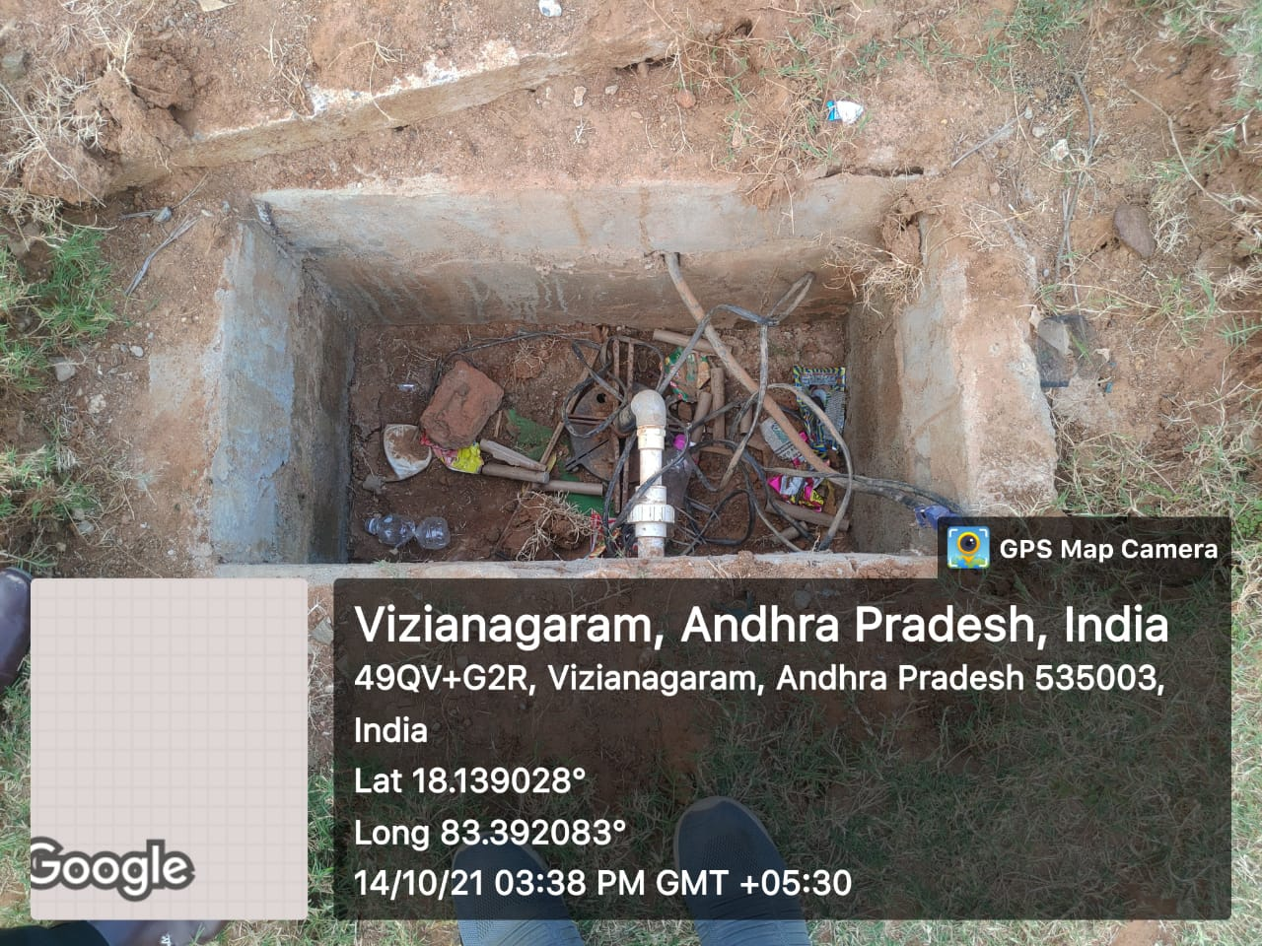

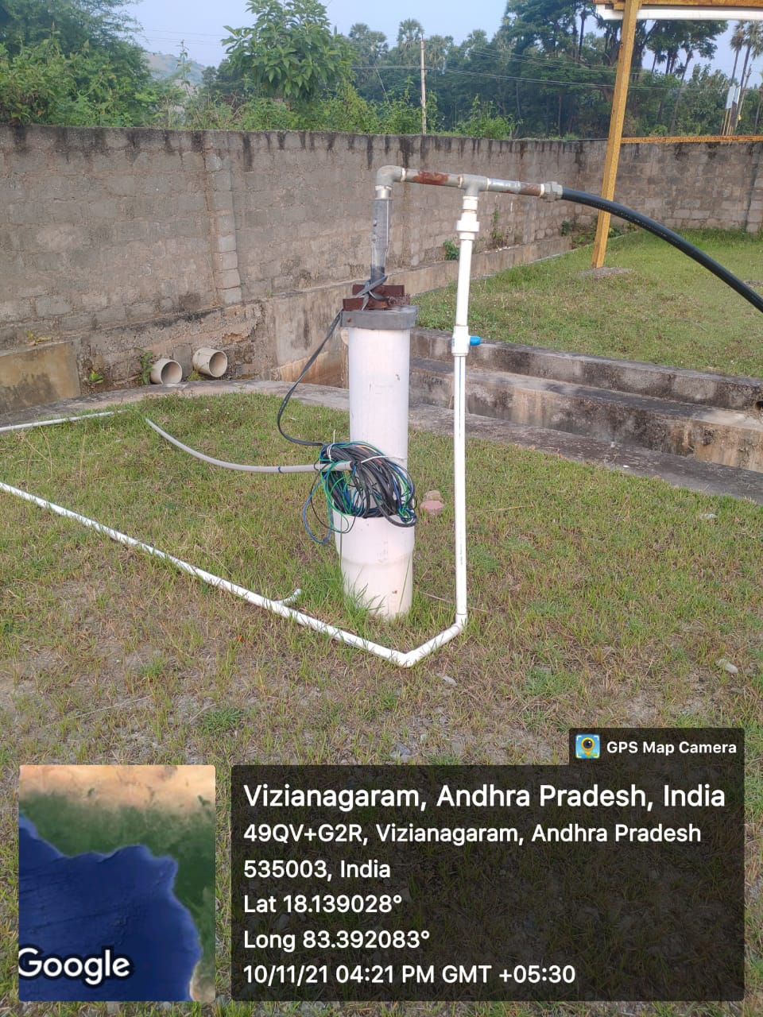

3. CONSTRUCTION OF TANKS AND BUNDS
A contour bund of size 240 m x 1m x 1m is created along the boundary of the college for the percolation of rain water.

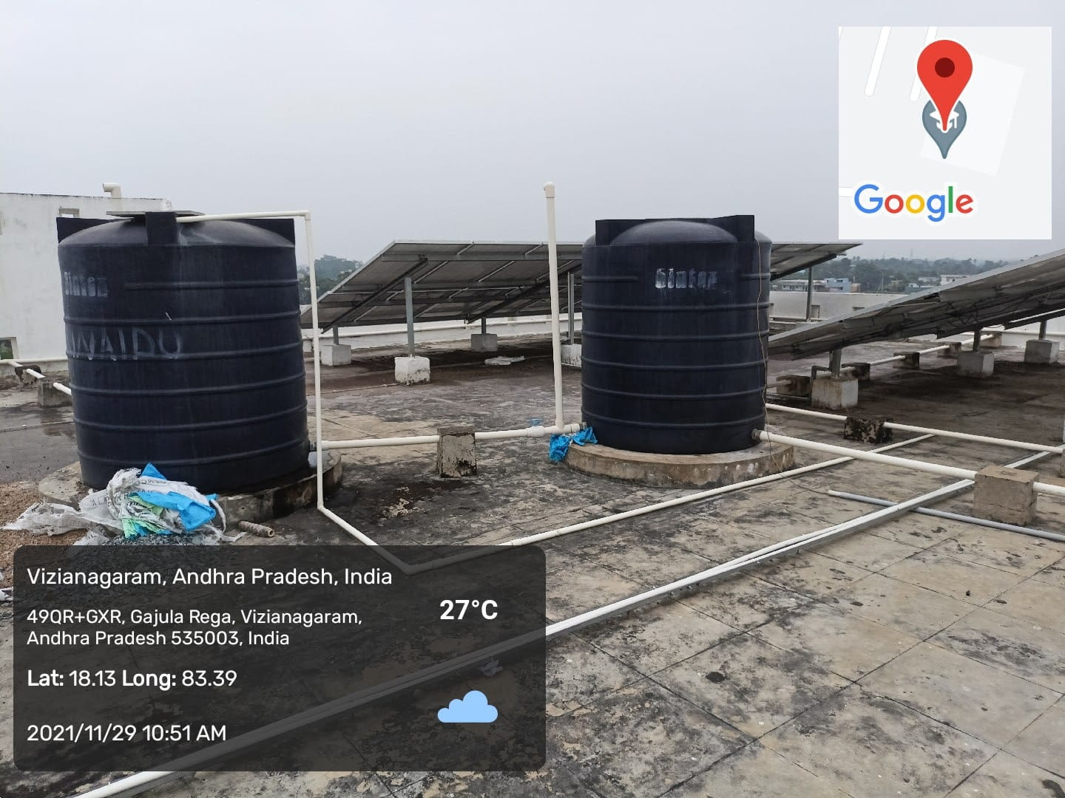
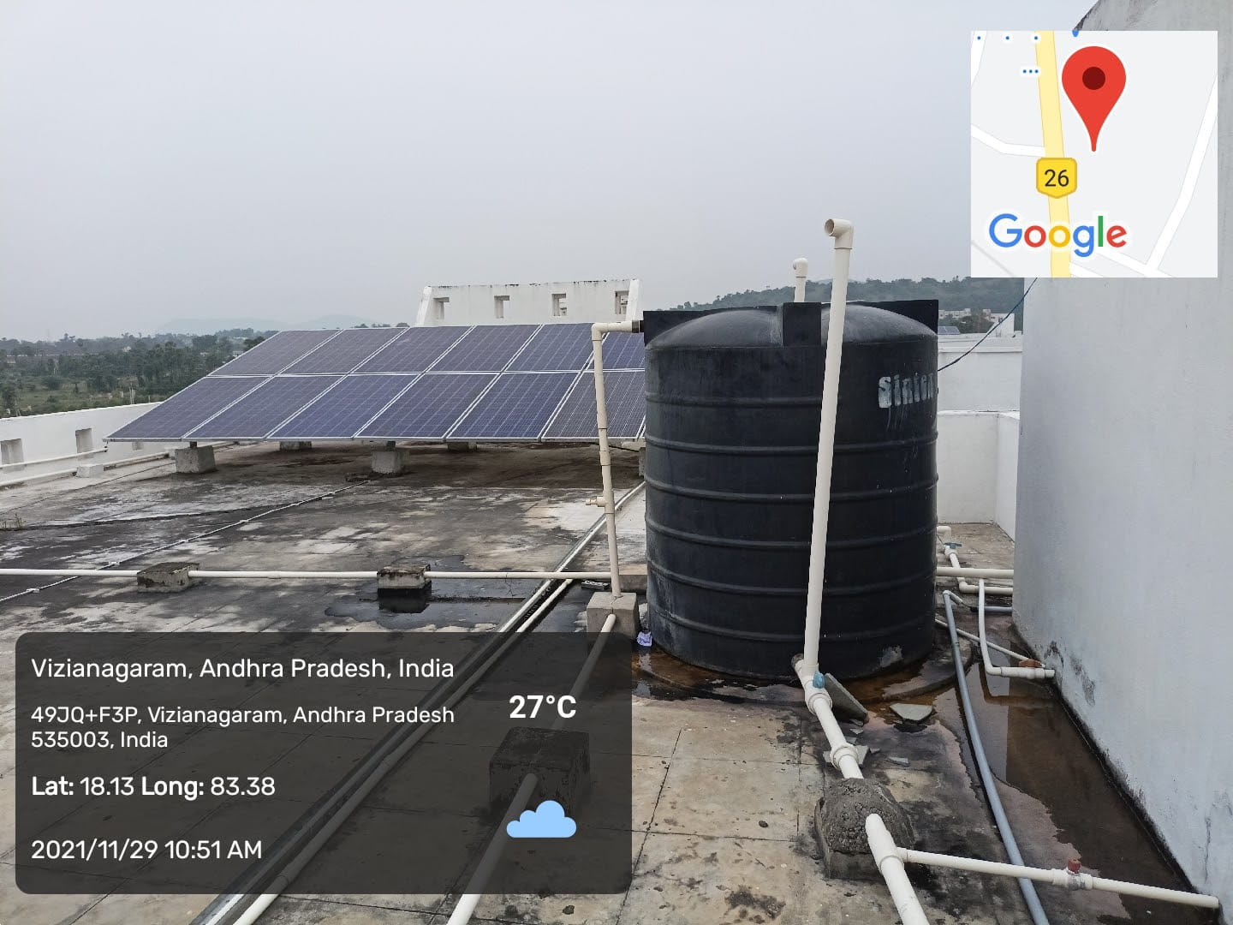
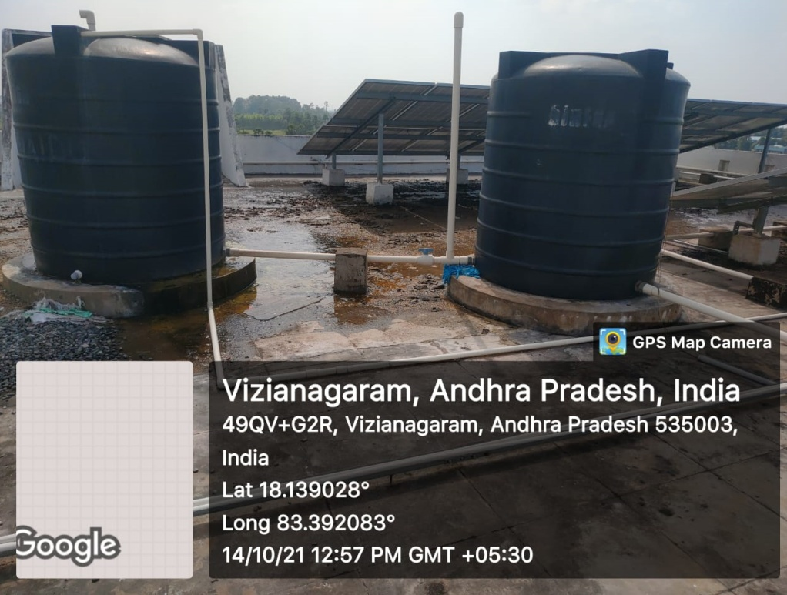

4. USAGE OF WASTE WATER
Wastewater discharged as effluent from canteen is used for gardening, watering of trees etc.

5. MAINTENANCE OF WATER DISTRIBUTION SYSTEMS IN THE CAMPUS
The ground water is pumped into storage tanks located at different places in the campus. There are several numbers of over head storage tanks in the campus. The water is distributed through well laid pipe network. Drinking water after treating in RO plant is supplied through a separate set of distribution pipes and water for all other purpose is supplied through another set of distribution pipes. Entire distribution system is well supervised by Civil works committee to ensure that there are no leakages and wastages of precious water through joints, valves etc. Waste water usage is reduced using low pressure flushes. All the stakeholders of the college are well educated to use water economically and efficiently.

