Four of the features listed under this heading are available in SITAM, Vizianagaram.
1. Solar energy 2. Biogas plant 4. Sensor-based energy conservation 5.Use of LED bulbs/ power efficient equipment.

1. Solar energy:

SITAM is environmentally safe Institute all through its stages of development. SITAM focuses on sustainable and renewable measures. Recognizing the need for sustainable ecosystem SITAM has put renewable energy practices and energy saving practices. Harvesting solar energy utilizing bio energy are two important energy generation and utilization practices. Similarly energy conversation through efficiency improving measures such as sensor based street lights low power consuming LED bulbs are important measures in SITAM.
The Institution has facilities for alternate sources of energy i.e. Solar Power Plant (Green Energy Production) with an installed capacity of 75 kW to save energy and to reduce the consumption of conventional power supply from Andhra Pradesh Eastern Power Distribution Company Limited (APEPDCL).

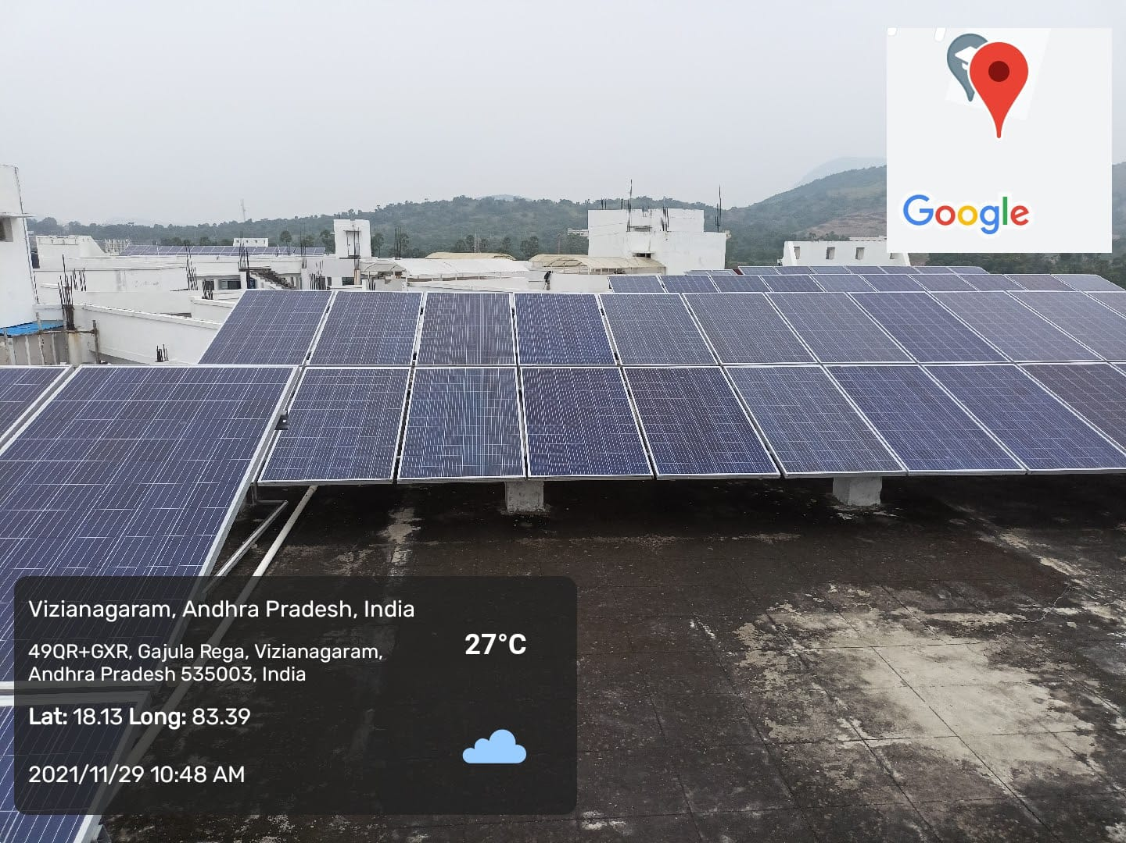

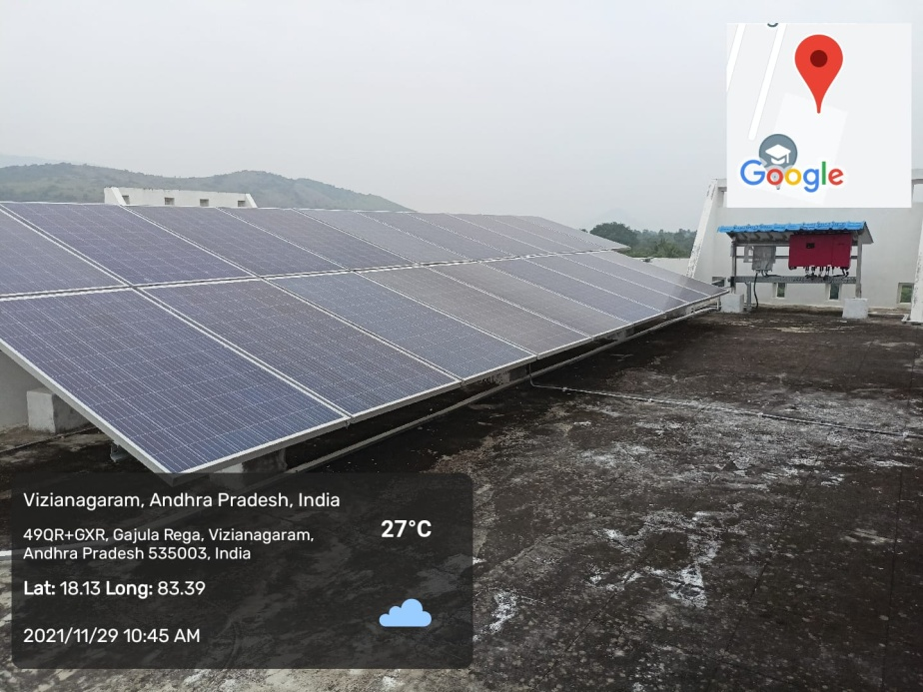

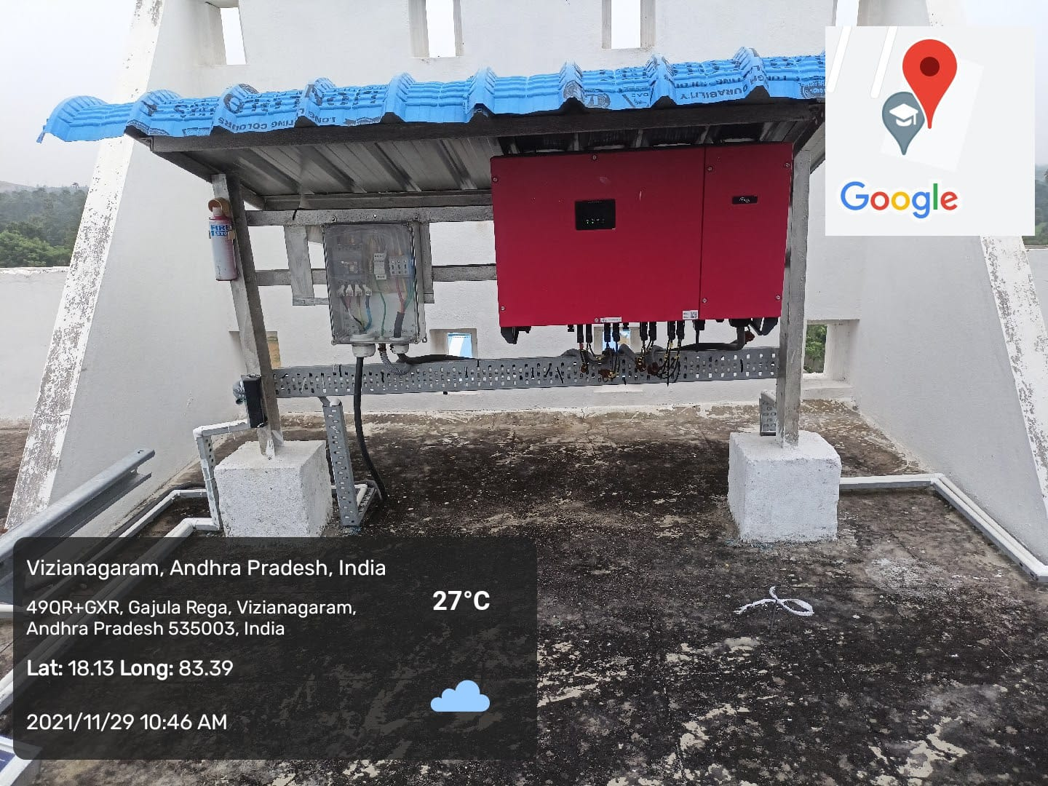

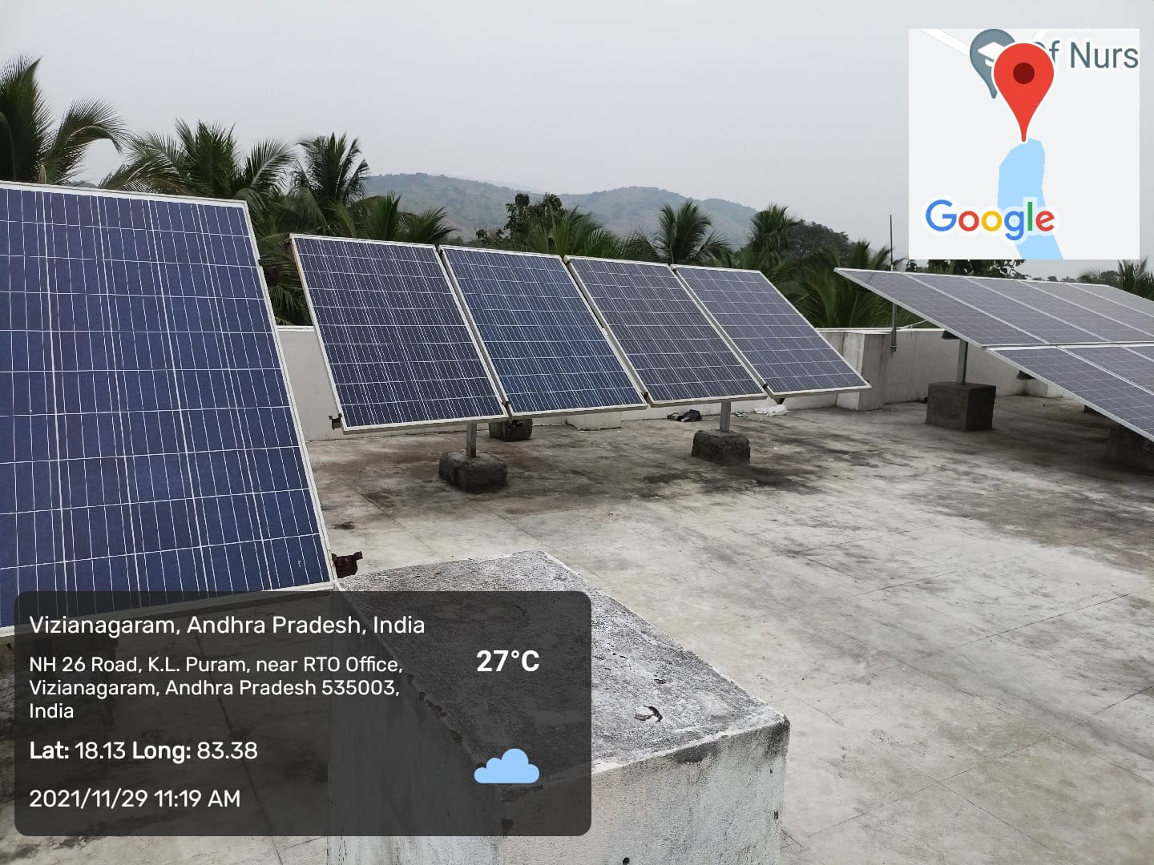

2. Biogas plant

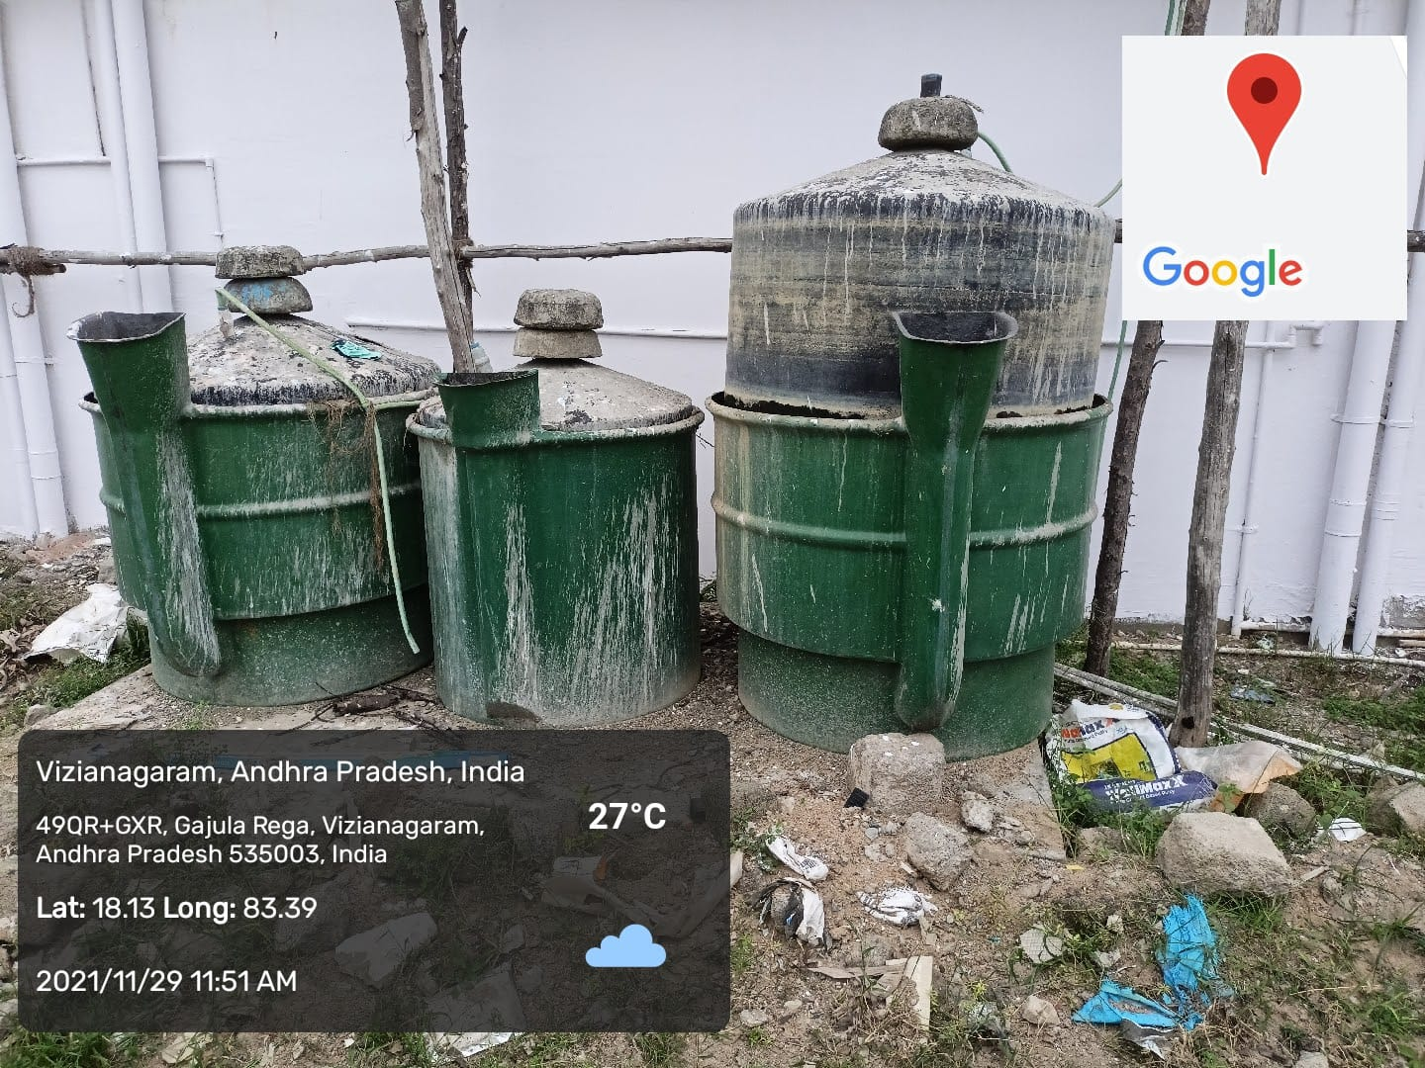

4. Sensor-based energy conservation
- Sensor based street lights
- Sensor based hand sanitizer
- Sensor based street lights

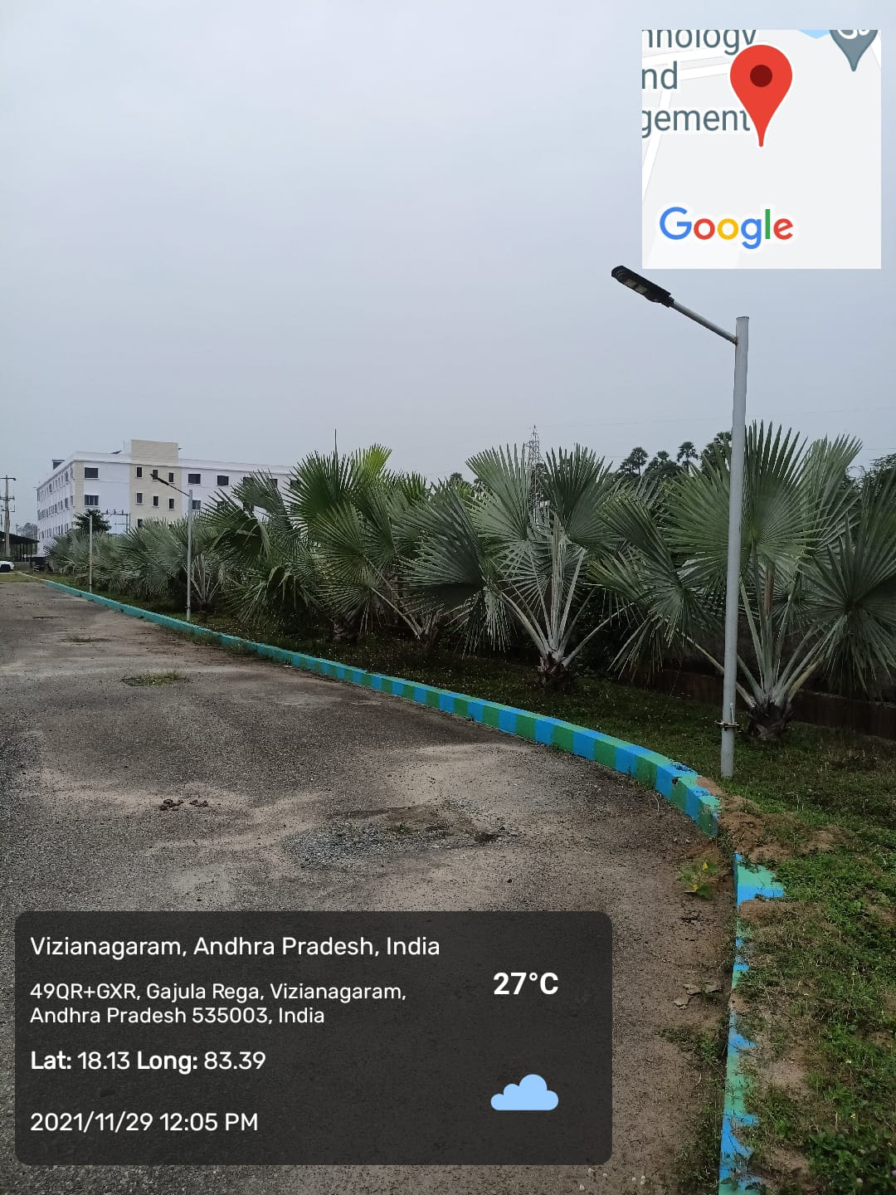

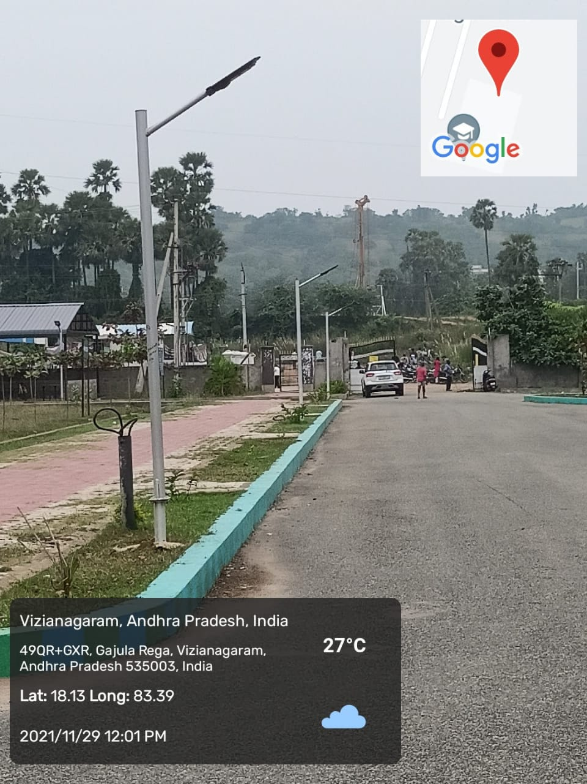

ii) Sensor based hand sanitizer

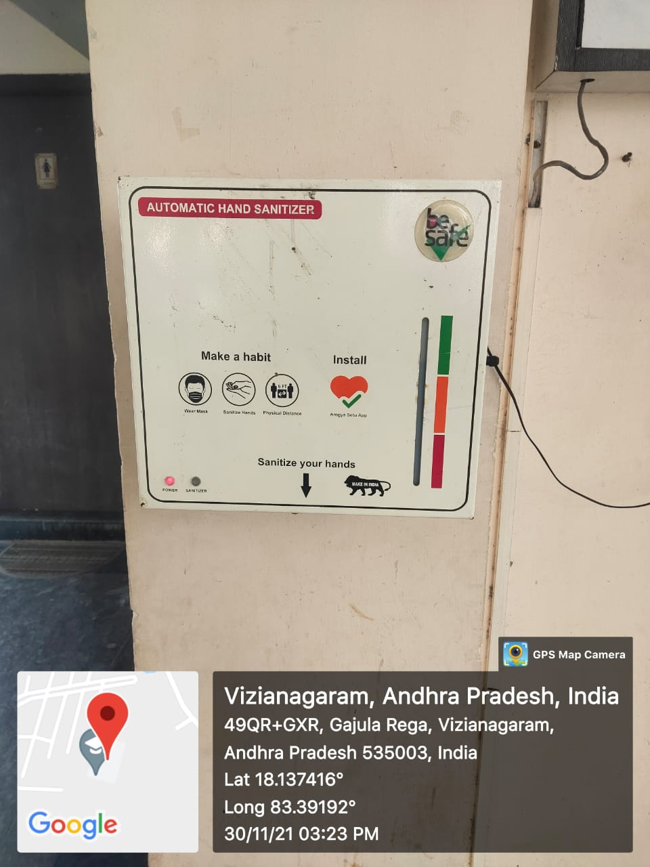
5. Use of LED bulbs/ power efficient equipment

