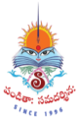
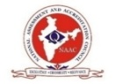
SITAM
SATYA INSTITUTE OF TECHNOLOGY AND MANAGEMENT
Gajularega, Vizianagaram, Andhra Pradesh, India-535002.
Accredited by "NAAC"
Approved by AICTE and Affiliated to JNTUK, KAKINADA
Email: sitam@sitam.co.in, Website:www.sitam.co.in
Telephone No:9676788811, 8978812341/2, Land Line: 08922-234775

IQAC- SATYA INSTITUTE OF TECHNOLOGY AND MANAGEMENT

Qualitative Metrics
Criterion 7-Institutional Values and Best Practices
Key Indicator 7.1 Institutional Values and Social Responsibilities
Institution celebrates / organizes national and international commemorative days, events and festivals
7.1.11

SITAM provides all inclusive environment to foster tolerance and harmony towards cultural, regional, linguistic, communal and other socioeconomic diversities. As a preliminary practice, all persons are encouraged to restrain anger and hatred in all situations. They are reminded the motto of the institute Panditaha samadrsinaha.

SITAM organizes national festivals, birth and death anniversaries of great Indian Personalities, and most, if not all the several important days of historic and cultural importance of which some are mentioned below:
- National MathematicsDay
- Independenceday
- MakarSankranti
- Republicday
- Scienceday
- Teachersday
- Ganeshjayanthi
- Women’sday
- Diwali
- YogaDay
- Engineer’sday

The institute recognizes the importance of national commemorative days and celebrates on the respective days. These programmes are organized with motivational and inspirational speeches by eminent persons.

Independence day and Republic day are celebrated for understanding integrity. Science day, Mathametics day, Teachers day and Engineers day are celebrated in the Institute. Festivals like Diwali,Ganesh jayanthi are also celebrated for the purpose of welfare.

Name of the event: 75th Independence Day celebrations at SITAM Date: 15-08-2021
The national tricolor was unfurled amidst festive gusto in the SITAM campus in Vizianagaram. Chairman of Stay Fit Health and Fitness World Pvt Ltd, Bangalore , Dr. G. K. Ganapati unfurled the national flag and addressed the audience on the occasion. Besides the NCC Marching parade, the acrobatic performances of NCC cadets and various performances by the students stood as special attractions in the celebrations.
In addition the students performed song and dance sequences to depict our culture of patriotism. In this glorious event organized by Satya Institute of Technology and Management, several prizes were distributed for the winners of various sports events.
As a tradition, Government servants, Social Activists and Philanthropists were honored along with distinguished Alumni. Dr M. Priyanka of MR Hospital, Dr. Divya Deepti of Ghosha Hospital Were among the honored. Distinguished alumni Sri M. A. Naidu, currently working as Jailer in Eluru and Smt T. Chittemma currently working as Constable in Vizianagaram Rural Police Station were specially honored for their unflinching service during the Covid pandemic period. Recognizing the contributions in the relief operations during the pandemic, founder of Spark Society gave away mementos to 50 NCC cadets of the Institute.
Smt. Srilakshmi, Social activist and president medal winner and Mr. Ram, MD of stay Fit also participated and shared their life experiences and wished the students to come up in life in their chosen fields by staying fit Physically and Mentally.
Chairman and Secretary and Correspondent of Satya Group of institutions, Sri Botcha Satyanarayana and Dr. Botcha Jhansi Lakshmi sent their greetings and best Wishes on the occasion.
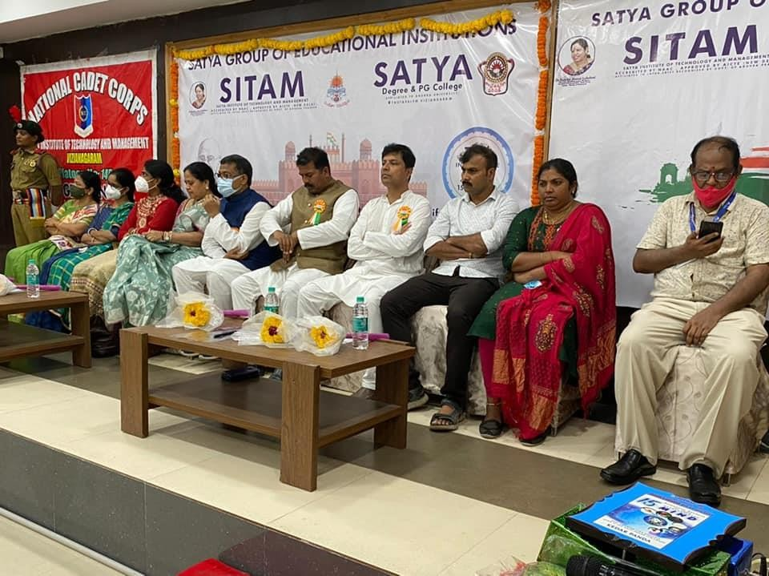
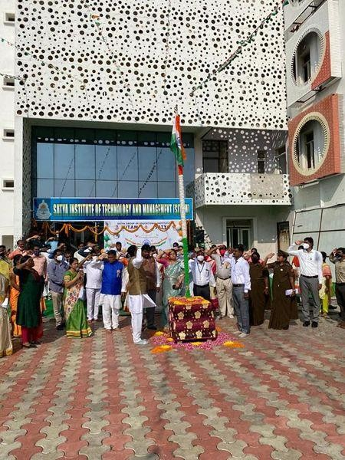

Name of the Event: Teachers Day at SITAM

Date:05-09-2021
Teachers Day was celebrated in the divine memory of Sri Sarvepalli Radha Krishnan at SITAM Engineering College. On this occasion games, songs, dance competitions were organized for the teachers. Prizes were distributed to the winners.

Special prizes were awarded to those who published research articles and to those who .Sri Dosapati Chaitanya and Sri Karunakar dance performances impressed everyone .

On this occasion Chairman Sri. Botcha Satyanarayana, Secretary and Correspondent Dr. Botcha Jhansi Lakshmi conveyed their wishes to the faculty.
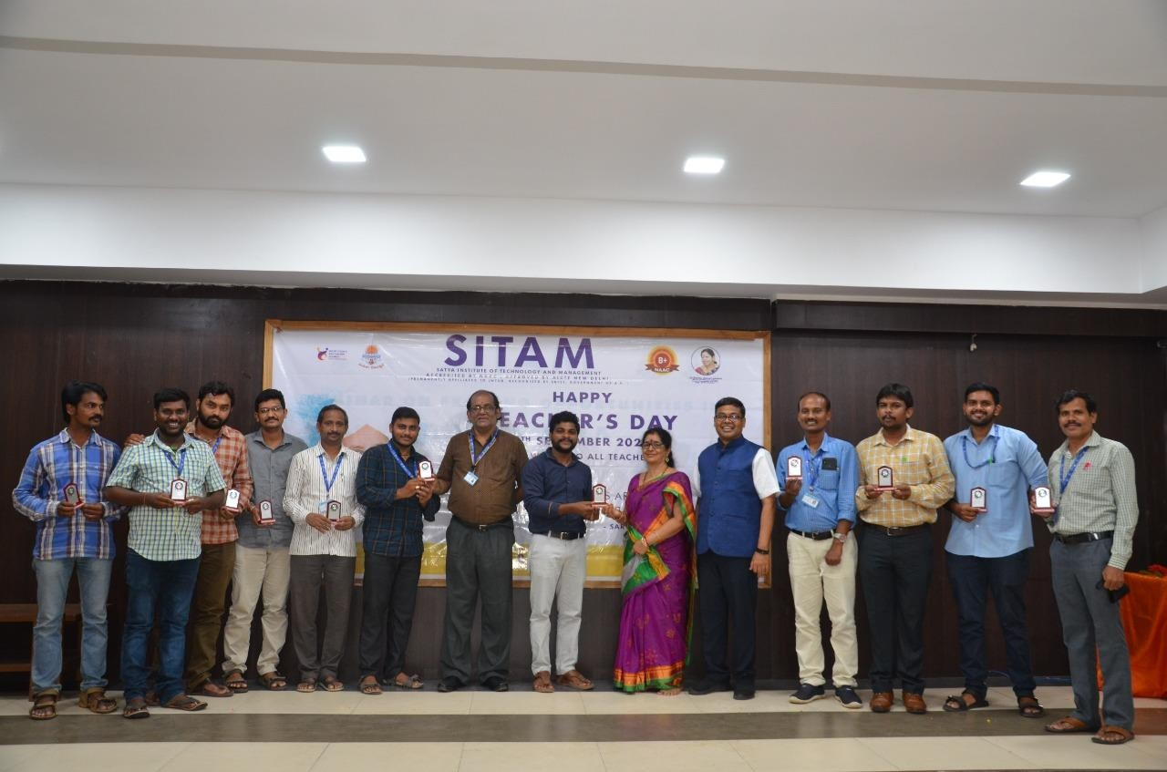

Name of the Event:Distribution of Lord Ganesha Statue at SITAM Date:10-09-2021
Lord Ganesha statues made of Pancha Gavya composite clay were distributed at SITAM Engineering College.
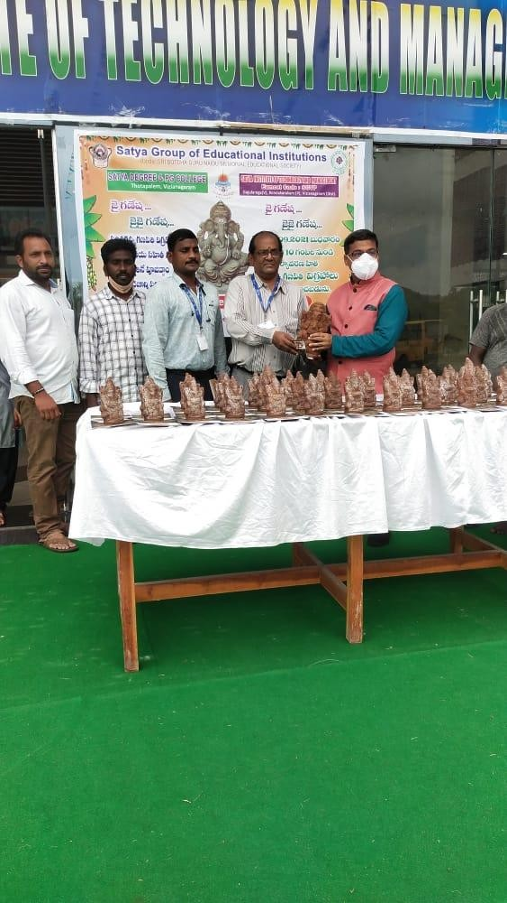
Teachers, non-teaching staff, students and dignitaries were overjoyed to receive the Ganapati Vrata Vidhana book in the hands of the College Director Sri Majji Sashibhushan Rao. Satya College Chairman Sri Botcha. Satyanarayana and Secretary and Correspondent Dr.Botcha JhansiLakshmi conveyed their wishes to all the members of Institution .

Name of the event: DIWALI CELEBRATIONS Date:04-11-2021
Diwali Festival was celebrated in the campus of SITAM College, Vizianagaram on 4th November 2021 with full zeal and fervor.
Diwali is a festival of lights and togetherness. It is the festival of Unity.Diwali is Celebrated to foster and benevolence.
The event was hosted by Dr.Majji Sashi Bhushan Rao, Director, SITAM College. The chief guest of the function was former Member of Parliament from vizianagram Dr. Botcha. Jhansi Lakshmi ,Smt.Majji Anuradha and SITAM College Principal Dr. Sri Rammurthy and warden Smt.Satyaveni and SITAM staff, students participated in the Diwali celebrations and made the event asuccess.
The Director and The Secretary and the faculty members exchanged advanced Diwali greetings to be celebrated on 4thNovember 2021. Sweets and savories were distributed to all the staff members.
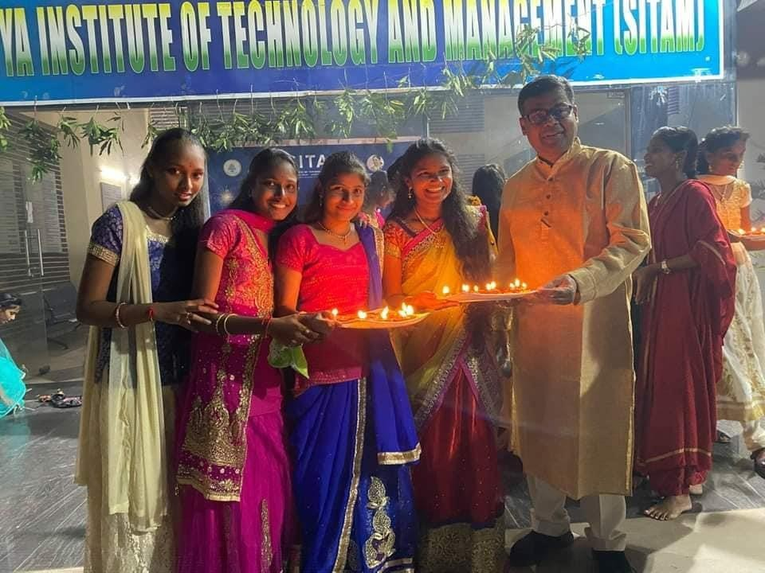

Name of the event: Engineers Day at SITAM College Date:15-09-2021
"Bharata Ratna" Mokshagundam Visvesvaraya's Jayanti was celebrated as "Engineers' Day"at the SITAM College. Dr. B. Santosh Kumar, Deputy Executive Engineer, Irrigation Division, Vizianagram ,as the chief guest, Sri Jaya Krishna, Fine Aspects DG, Robotics Lab, Visakhaptam as a guest of honor.
On the occasion of Engineers' Day, technical competitions such as Project Expo were organized for the students.
Dr. B. Santosh Kumar said that there is an inseparable link between theory and practice, that the curriculum is easily understood if students read it diligently, and that students should show enthusiasm in reading.
College Director Dr.Majji Sashi Bhushan Rao explained the importance of Engineer's Day and the importance of this year's Engineer’s Day theme "Engineering for a Healthy Planet" and wished all students to develop technical skills and make India proud engineers.
Sri Jaya Krishna addressed the students on Robotics Design and Development in India, Artificial Intelligence, and Internet of Things etc.
The Principal of the college Dr. D.V. Ramamurthy explained the responsibility of the engineer towards the society.
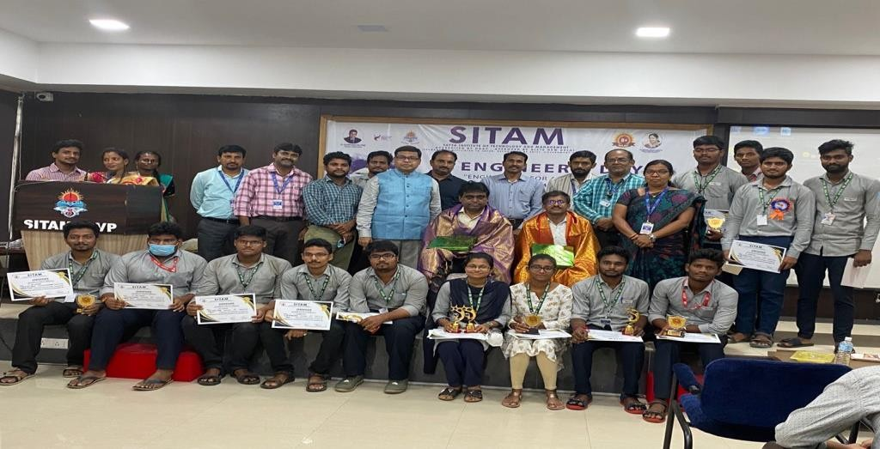
He then congratulated the faculty who published prizes and papers to the students who won the competitions. The event was attended by students and faculty.

NAME OF THE EVENT: SANKARANTHI CELEBRATIONS AT SITAM COLLE
DATE:13-01-2022

Former Member of Parliament Dr. Botcha Jhansi Lakshmi wished to observe Sankranti celebrations while maintaining social distance. New clothes were distributed on a large scale in honor of Sankranti at SITAM Engineering College on13-01.2022. She handed over the gifts, while showing love to those who come from faraway places to celebrate Sankranti.

Dheera Convener Dr. Botcha Sandeep congratulated the staff in the program. Director of SITAM Dr.Majji Sashi Bhushan Rao, SITAM Principal Dr.D.V. Ramamurthy, Satya Degree College Principal Mrs. Sai Devamani, SITAM Vice Principal Dr. Damodar Naidu, Captain Satyaveni and others were present.

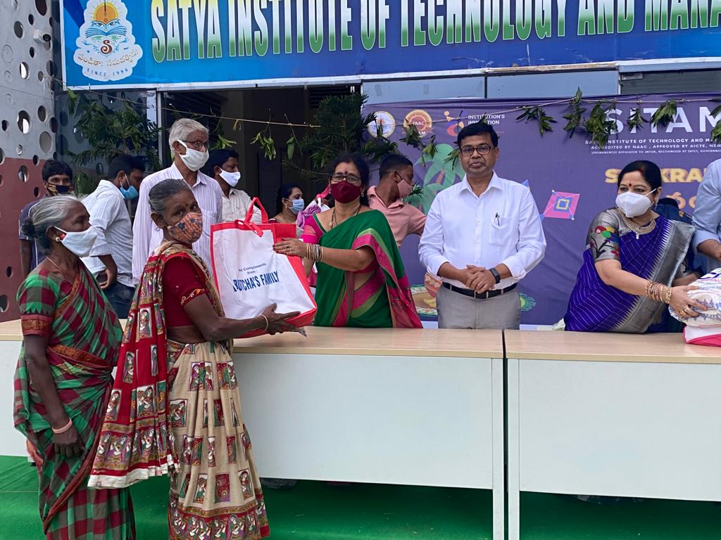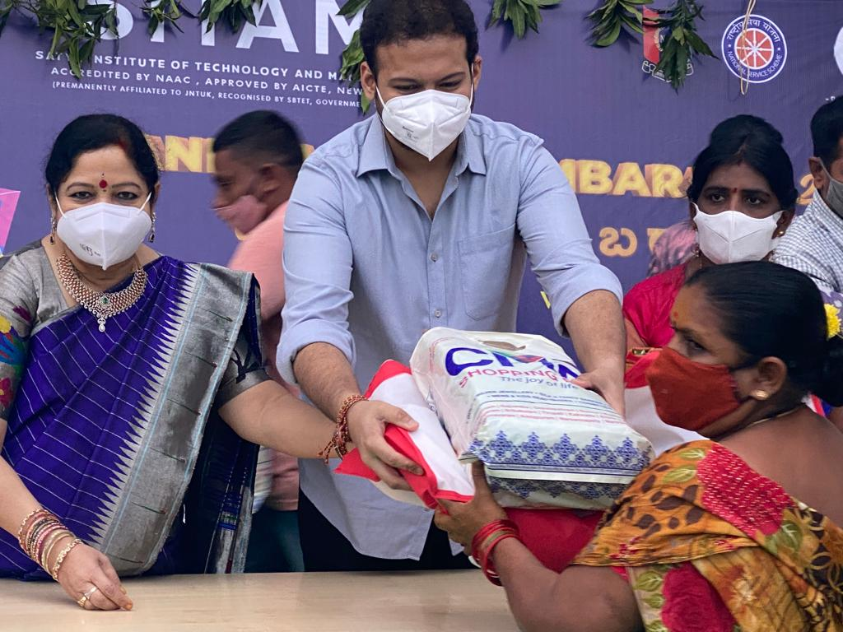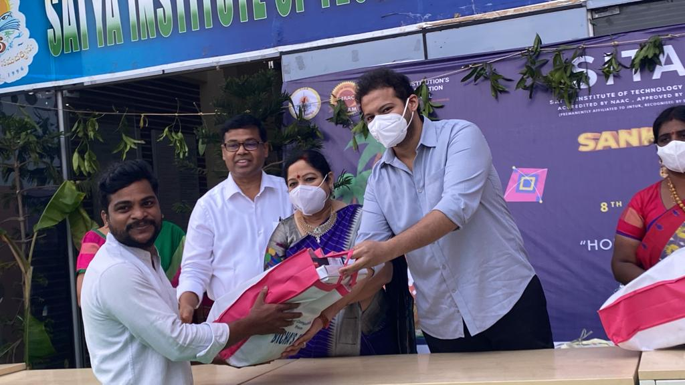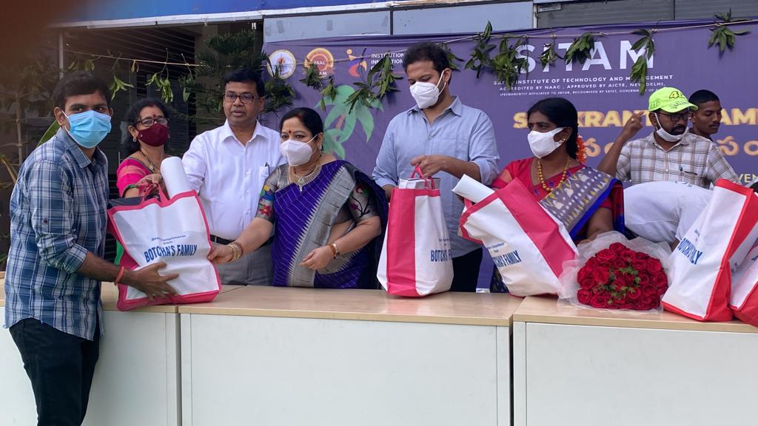

NAME OF THE EVENT: REPUBLIC DAY CELEBRATIONS AT SITAM ENGINEERING COOLEGE

DATE :26/01/2022

SITAM Engineering Colleges organized the 73rd Republic Day celebrations in the SITAM Engineering College Campus .

The celebrations started with flag hoisting by the Director Dr. Majji Sasi Bhushan Rao

On this occasion, parade, drill and pyramid formations by NCC students were the main attraction. On the occasion of Republic Day, Denkada Police Station Constable Mr. Nadukuru Ishwara Rao , Youth Foundation Founder and President Mr. Shaik Iltamush , Secretary Youth Foundation Vizianagaram and Life Spring Ambulance Service Owner Mr. Chitthuri Tirupati Rao , Garugubilli RMP for their services.Dr. Majji Sasibhushan Rao, the director of the college honored them as recognition.

In this ceremony, Mrs. Anuradha, Dr. T. DamodarVice Principal of SITAM College, , Dr. M. V. Sai Devmani,Principal of Satya Degree College,NCC officers of the two colleges, Captain M. Satyaveni, Lt. M. Varalakshmi, NCC Caretaker P. Prashanth, CSO Sri. Satyanarayana, teachers and students participated.

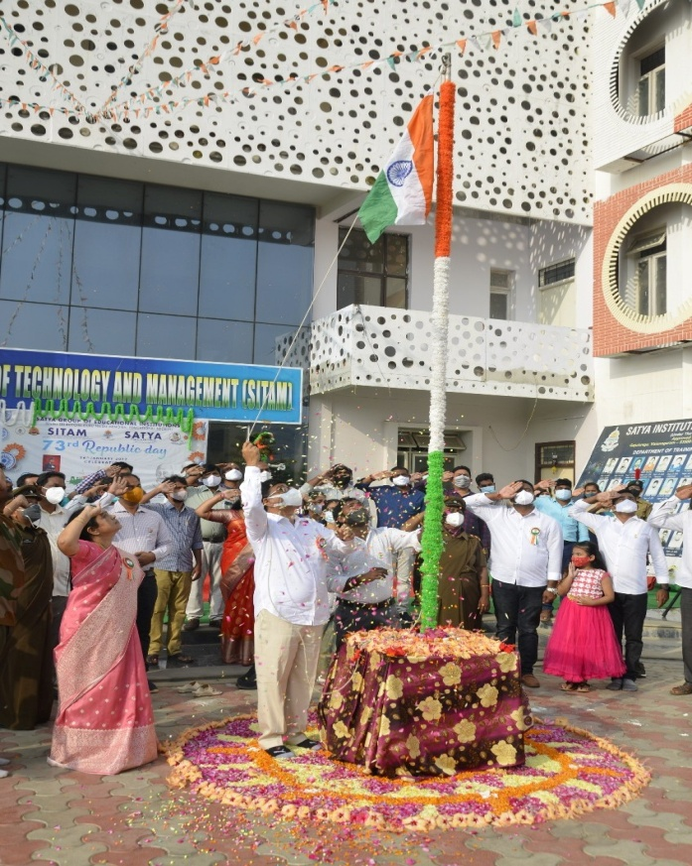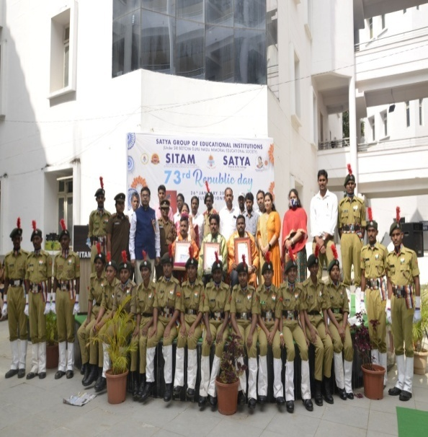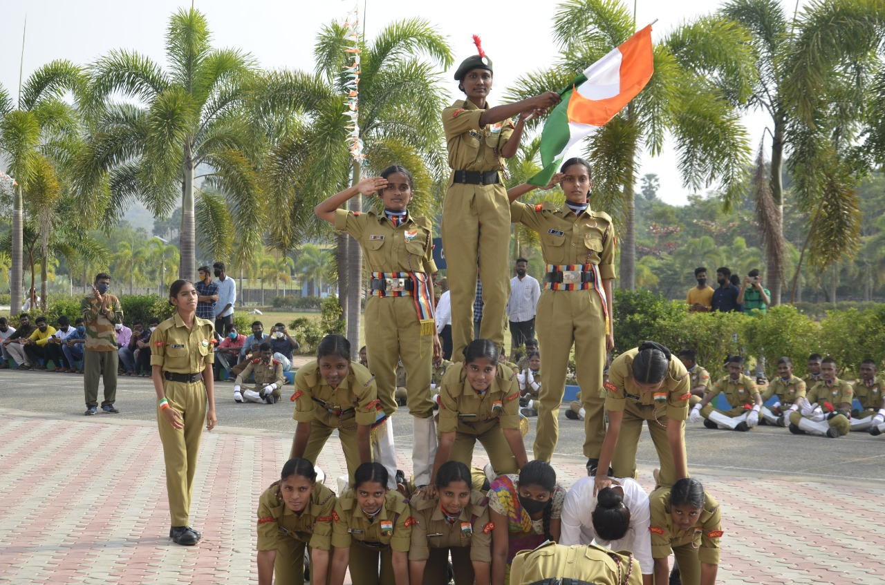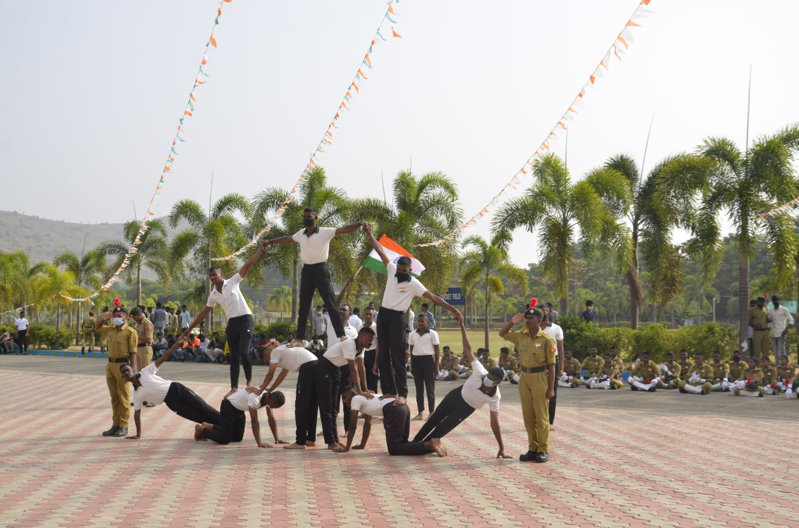

NAME OF THE EVENT:NATIONAL SCIENCE DAY AT SITAM ENGINEERING COLLEGE

DATE:28/02/2022

The National Science Day celebration was held grandly in the SITAM Engineering College. CSIR, CSIO Dr. C. Ghanashyam, who was the chief guest of the ceremony, explained the theme of the National Science Day and shared his experiences with the students.

On the occasion of National Science Day, quiz and poster presentation competitions (Theme: Integrated Approach in Science and Technology for Sustainable Future) were organized for the students and the winners were presented with certificates and gifts by the guests.

In this meeting Dr. Majji Sasibhushan Rao, Director of SITAM Engineering Colleges said that, if we work with dedication, the recognition will come and the day the world recognizes our talent, we will be fulfilled. Dr. D.V. Ramamurthy, Principal of SITAM , said that education should bring humility and curiosity to the students.

In this program, SITAM faculty and students participated. Dr.Botcha Jhansi Lakshmi, Secretary and Correspondent of SITAM Colleges and Dr. Botcha Satyanarayana, Chirman of SITAM conveyed their wishes to all members congratulating one and all for organizing such programs.

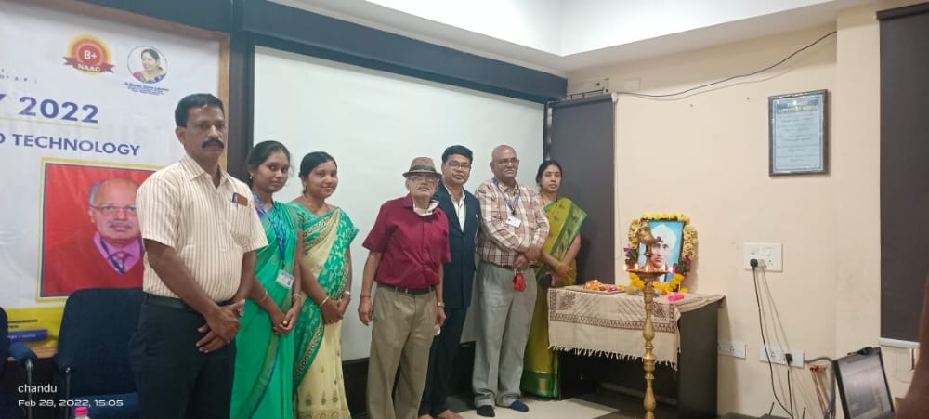

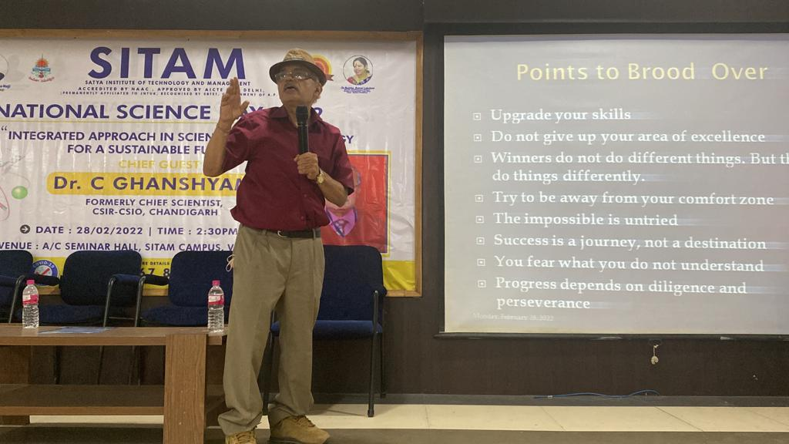

NAME OF THE EVEN : INTERNATIONAL WOMEN’S DAY

DATE :08/03/2022

International Women's Day was celebrated by SITAM Engineering College.

On this occasion, various games competitions were organized for the female faculty, elocution competitions and group discussion competitions were organized for the students and prizes were awarded to the winners.

Arts and crafts were exhibited by the students. Dr.Botcha Jhansi Lakshmi, Secretary and Correspondent of SITAM, Deputy Civil Surgeon Dr.T. Gouri Rama Lakshmi, Government Degree College Principal Dr. Swapna Hyndavi, MR Sangeeta College Music Teacher

Dr. Mandapaka Nagalakshmi, Annadata Sukhibhav Founder Smt. D.V. Kanchana, Social Service Worker Mrs. V. Santoshi was invited and felicitated.

On this occasion, the dance performances of the students entertained. Dr. T. Gauri Rama Lakshmi said that although women are moving forward in all fields, they are still being discriminated against, and women should not ignore their responsibility as mothers at any level, women should be mentally and physically strong. She said that healthy society helps in building a healthy society

.

Government Degree College Principal Dr. Swapna Hyndavi said that women should have self-confidence and women are strong wherever they are. Women should encourage their children in the fields of their interest and students should focus on learning fine arts to gain mental peace.

Annadata Sukhibhav Founder Smt.D.V. Kanchana advised the students that no matter what level we are, we should not forget our mother. College Secretary and Correspondent Dr. Botcha Jhansi Lakshmi said that everyone should fight against gender discrimination in the society and that women are excelling in all fields at par with men.

Dr. Majji Sasibhushan Rao, Director of SITAM, Dr. D. V. Rammurthy, Principal of SITAM College, Dr. M. V. Sai Devmani, Principal of Satya Degree and PG College, SITAM Vice Principal Smt. Venkata Lakshmi, teachers and students are participated.

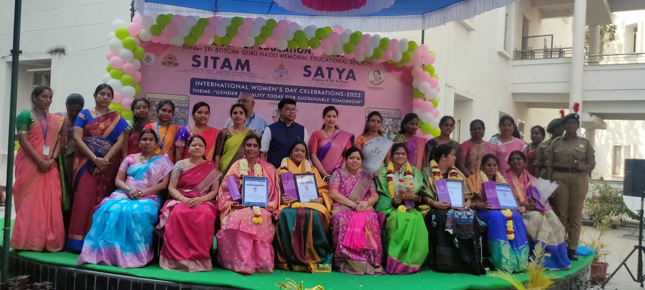

NAME OF THE EVENT: NATIONAL MATHEMATICS DAY

DATE :22/12/2021

National Mathematics Day was celebrated on the occasion of the birth anniversary of mathematician Srinivasa Ramanujan in the SITAM Engineering College. JNTU College of Engineering Vizianagaram, Assistant Professor of Mathematics Dr.A. V. Paparao said that students should make proper use of four years of engineering so that they can continue in their career without any worries, every engineering student should study mathematics in depth as needed, students should set a goal and work hard to achieve it, and learn something new every day.

The Director of the college Dr. Majji Sasibhushan Rao said that the students should remove their fear of mathematics and if they master mathematics, they can easily understand engineering subjects. Principal of the college Dr. D.V. Rammurthy advised the students to develop interest in mathematics. Teachers and students participated in this program.

On the occasion of Mathematics Day, quiz and power point presentation competitions were organized for the students and prizes were awarded to the winners and mathematics teachers were felicitated.

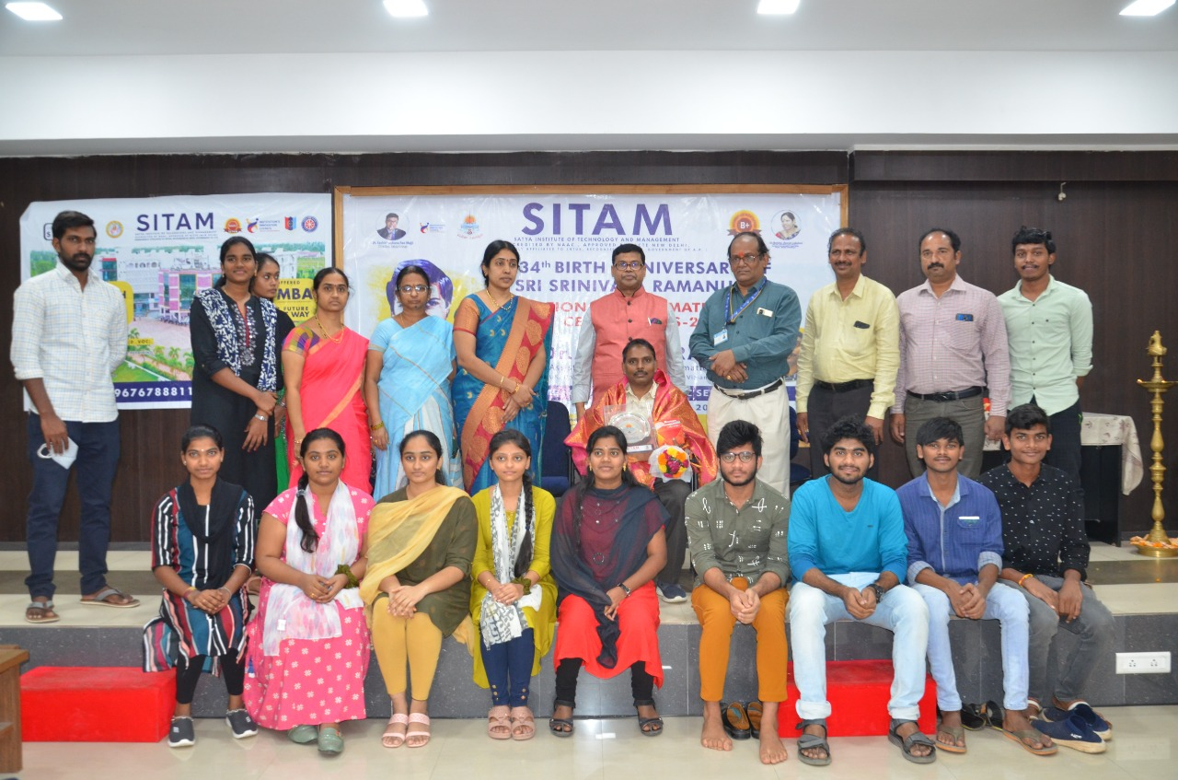

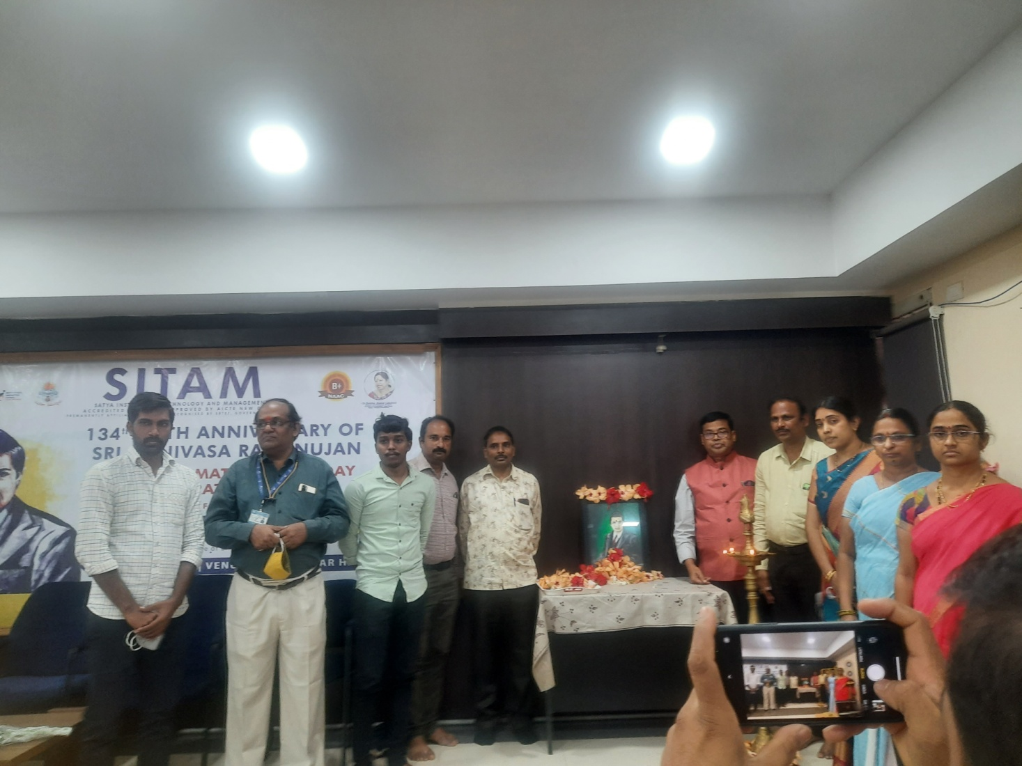

NAME OF THE EVENT: INTERNATIONAL YOGA DAY

DATE : 21/06/2022

Yoga Guru Sri. B Papa Rao emphasized the importance of yoga for good health and said that “Om” is oxygen to our body. He was the chief guest at the International Yoga Day organized by Satya Group of Educational Institutions. The students and NCC cadets were briefed on the need to develop "Yoga for Mankind" for the physical, mental and spiritual well-being of mankind, thereby progressing in all spheres, and practiced various yoga mudras, asanas and breathing exercises.

On this occasion, Director of Satya educational institutions Dr. Majji Sasibhushan Rao said that students should leave their differences with others and should not get into the habit of thinking negatively for our health.

The NCC cadets said that the session of Yoga Guru Shri Papa Rao was useful for them in improving their memory and concentration and it will improve their education.

On this occasion, Principal of Satya Degree College Dr. Saidevamani thanked the chief guest

Mr. B.Paparaofor motivating the students towards yoga by organizing yogasanas in a cheerful and humorous manner.

SITAM Principal Dr. D.V. Rammurthy, Lt. Varalakshmi, Captain Satyaveni, Caretaker Prashant, physical education teachers and staff of both educational institutions participated in the program.

