Qualitative Metrics
Criterion VI-Governance, Leadership, and Management

6.3.1 The institution has effective welfare measures for teaching and non-teaching staff.

Employees are undeniably crucial stakeholders who influence organizational effectiveness by stabilizing the adaptive environment. The management of SITAM implemented various monetary as well as non-monetary welfare measures for employees. Monetary welfare schemes are
      - Employees Provident Fund as per PF rules
      - Salary advance facility for teaching and non teaching staff in case of urgency.
      - Medical Leave & Maternity/Paternity leave for eligible staff members

4. Employee gets fees concession for their ward.

5. Leave for higher education .
6. Subsidized food in the canteen.
7. As Institution has a multicultural environment in the campus, the management ensures the celebration of all the festivals together.
8. Internet and free Wi-Fi facilities are also available in campus for staff.
9. Women Empowerment Cell is established for creating venues for women members to flourish and gain momentum.
10. Lodging and boarding facility to the needy.
11. Summer Vacation for staff.
12. Free transport facility for all the staff

In a nut shell, the Institution strives hard to keep our staff happy and healthy.

Apart from monetary schemes, various non-monetary welfare schemes are provided to employees for their professional development. The schemes are listed below
- Immediate increments after earning Ph. D. Degree.
- Study leaves for Ph D, higher education and training programmes.
- Technical workshops are conducted to keep pace with syllabus and new technologies.
- Faculty development programs are conducted in the institute.
- Faculty members are encouraged to attend seminars and conferences.
- The institute motivates the faculty and staff for arranging / attending industrial training programs/ visits.
- Training programs are arranged for updating the knowledge of the non- teaching staff.
- Faculty members are encouraged and benefited from qualification improvement programs such as PhD by providing adequate time to under take course work and research work.

A sample of Maternity Leave sanctioned to Mrs.D.Bhavani of ECE Department is enclosed for your reference:

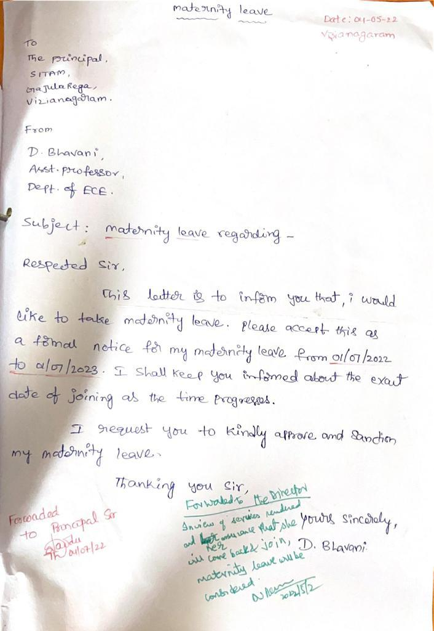

A sample of Medical Leave sanctioned to Mrs.V.N.Sireesha, of ECE Department is enclosed for your reference:
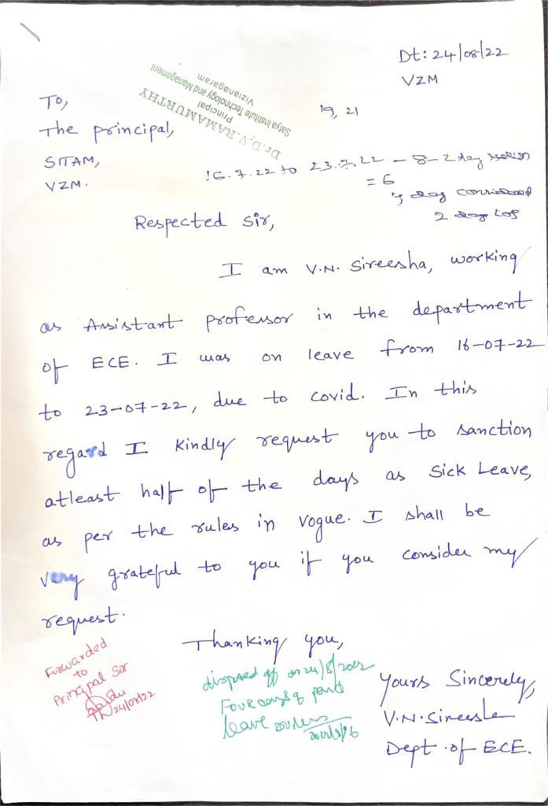

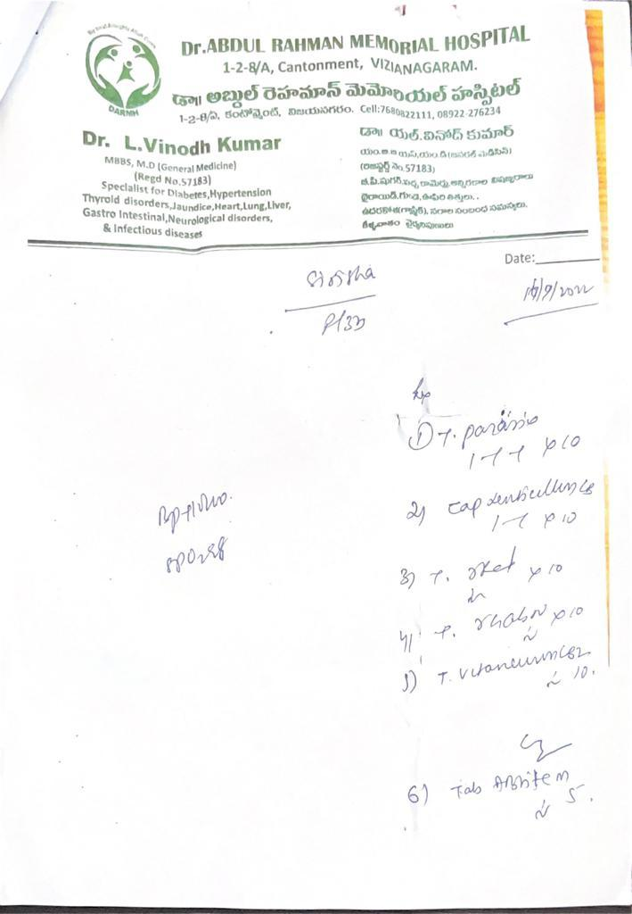

A glimpse of OD sanctioned to Mr.S.Prasanth, of Mechanical Department for the purpose of NCC is enclosed for your reference:

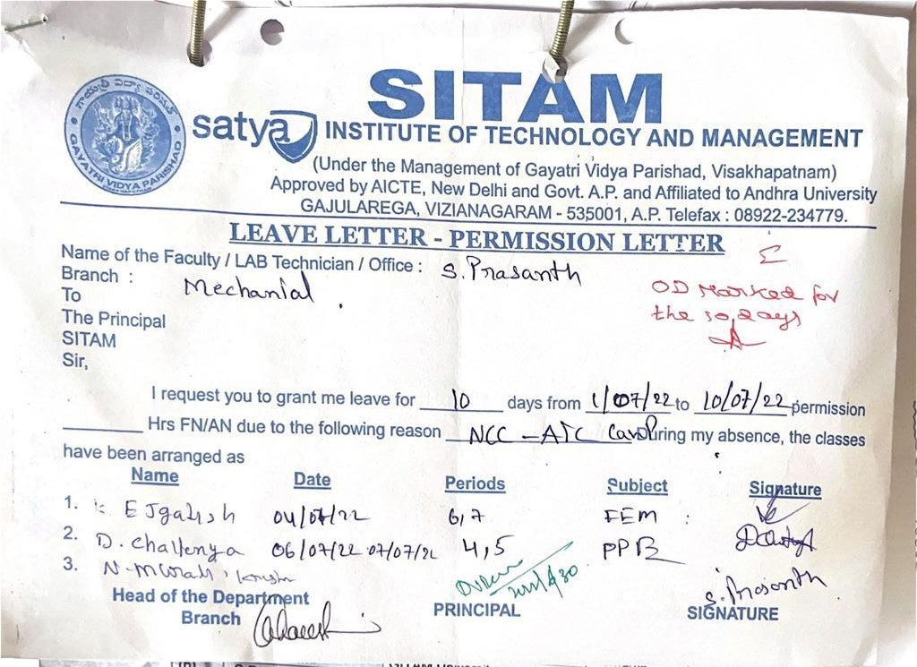

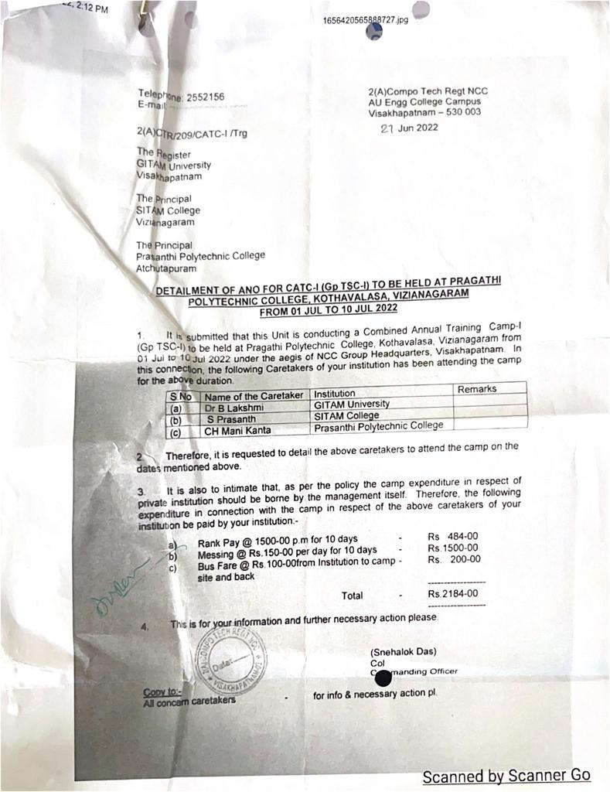

A glimpse of OD sanctioned to Mr.S.Prasanth, of Mechanical Department for the purpose of attending Training progarm is enclosed for your reference:

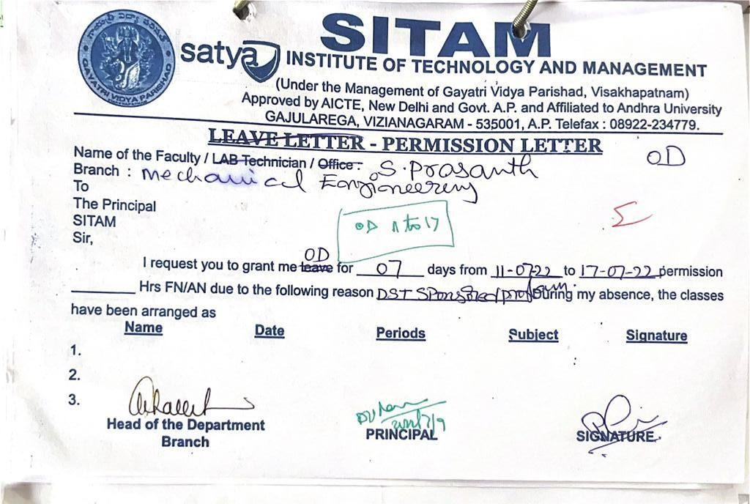

A glimpse of Provident Fund details of Mrs.V.Sirisha of ECE Department is enclosed for your reference:

