SITAM



SatyaInstituteofTechnologyAndManagement
NAACACCREDITED
ApprovedbyAICTE,NewDelhiandGovt.ofA.P.AffiliatedtoJNTUK,KAKINADA
Gajularega, Kondakarakam (P.O), Vizianagaram – 535003Contact:9676788811/9885758562,08922-234775/9
e-mail:sitam@sitam.co.in,principal@sitam.co.in,Facebook:sitam.sgvp,website:www.sitam.co.in
JNTUK Code:B6 EAMCETCode:SGVP
QualitativeMetrics
CriterionVI-Governance,Leadership, andManagement

6.2.1Perspective/StrategicplanandDeploymentdocumentsareavailableintheinstitution.

Strategic Plan (SP) with a long-term perspective is very vital for progress of any institution. Though the Strategic Plan may be subjected to changes as the institution learns from the curves and the bends of the SP. During the initial stages of the institute (first decade or so; a decade is almost ephemeral in the life of an Institution), faltering steps may have to be taken in planning and implementing a SP. Picture below shows the SP formulated at SITAM for it to walk into the "highway" of learning places and achieve its stated goals

.

The perspective plan, drawn during the academic year 2018-23, covered FIVE consecutive years spanning several events leading to permanent affiliation and NBA for a few departments.

The table below briefly describes the events stated in the Perspective plan shown above.

S.No. | AcademicYear | EventPlanned | OutcomeRealized
1 | 2019-2020 | Industry Interaction | Many industries are invited to SITAM for establishing mutually beneficial MoUs.  Internship potentialities for students are identified.
2 | 2019-2020 | Learning Management System | The LMS, uLektz is implemented in SITAM. Several quizzes and lot of digital content developed is placed on the "SITAM GVP-LMS"Application developed specifically for SITAM.
3 | 2019-2020 | NAAC | With severe competition, gearing up for systematization and getting external recognition becomes inevitable. Keeping this in view, NAAC accreditation is planned.
4 | 2020-2021 | New PG programs | Postgraduate programs serve as strengthening points of an education institution since research is facilitated by the presence of graduate students working towards their major project. One/two PG  Programs are being planned.
5 | 2020-2021 | Permanent Affiliation | Permanent affiliation obviates repetitive documentary and physical inspections and thus lot of time is freed for planning developmental activities. Besides Permanent Affiliation is a needed prerequisite for some of the governmental schemes.
6 | 2020-2021 | NBA | After the overall institute establishes itself as a stream of well laid procedures and is strengthened through prior activities, it then becomes imperative for the institute to strengthen its individual programs. This is the subsequent task.
7 | 2021-2022 | Autonomous | Autonomy gives greater flexibility towards purely academic development for improving academic standards and excellence. Promotes healthy practices such as community service, extension activities, projects for the benefit of the society at large and also promotes use modern tools of educational technology to achieve higher standards and greater creativity.
8 | 2021-2022 | NBA | Strengthening individual programs with  NBA accreditation validates quality standards which in turn improves student performance and fosters trust in the institution.

Satya Institute of Technology And Management is accredited by National Assessment and Accreditation Council (NAAC) with B⁺Grade.

- 1. The following picture presents the certificate of accreditation declared by National Assessment and Accreditation Council (NAAC) to Satya Institute of Technology And Management (SITAM).
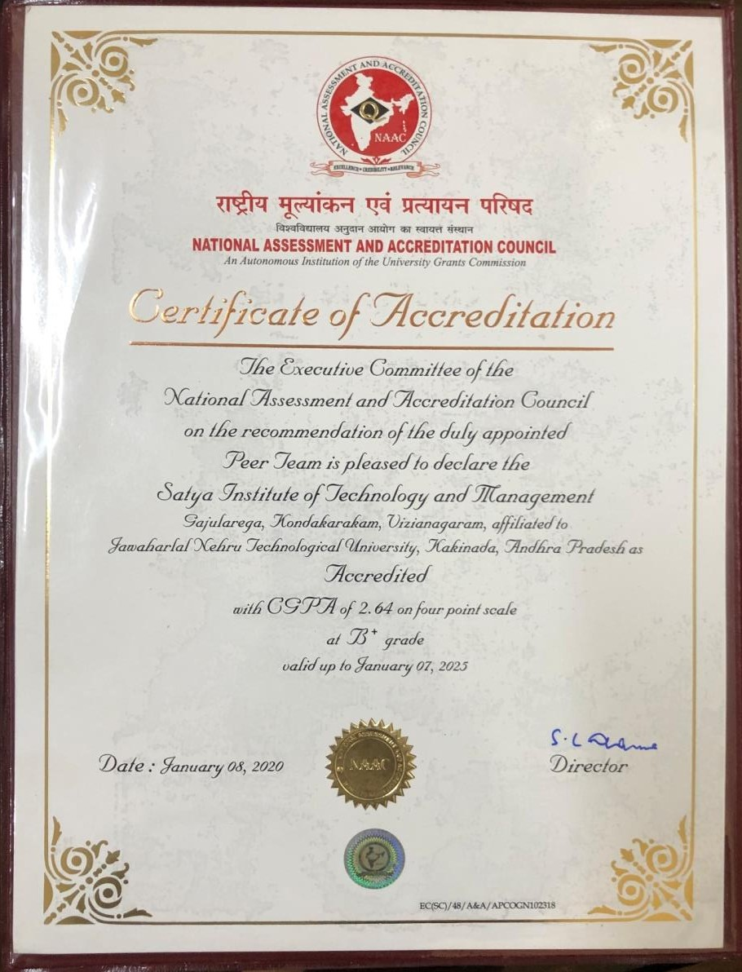

Satya Institute of Technology And Management is granted permanent affiliation to Jawaharlal Nehru Technological University–JNTU Kakinada.

- 1. The following picture represents the order issued to Satya Institute of Technology and Management, regarding the permanent affiliation to Jawaharlal Nehru Technological University–JNTU Kakinada.

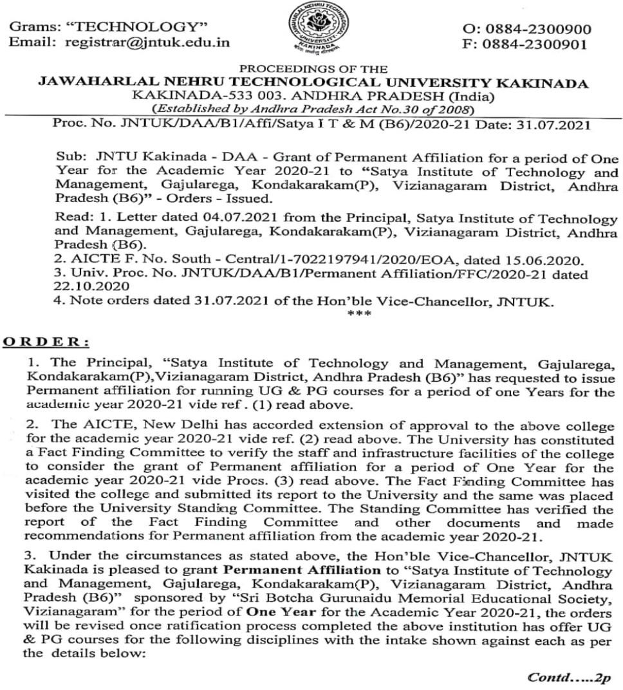

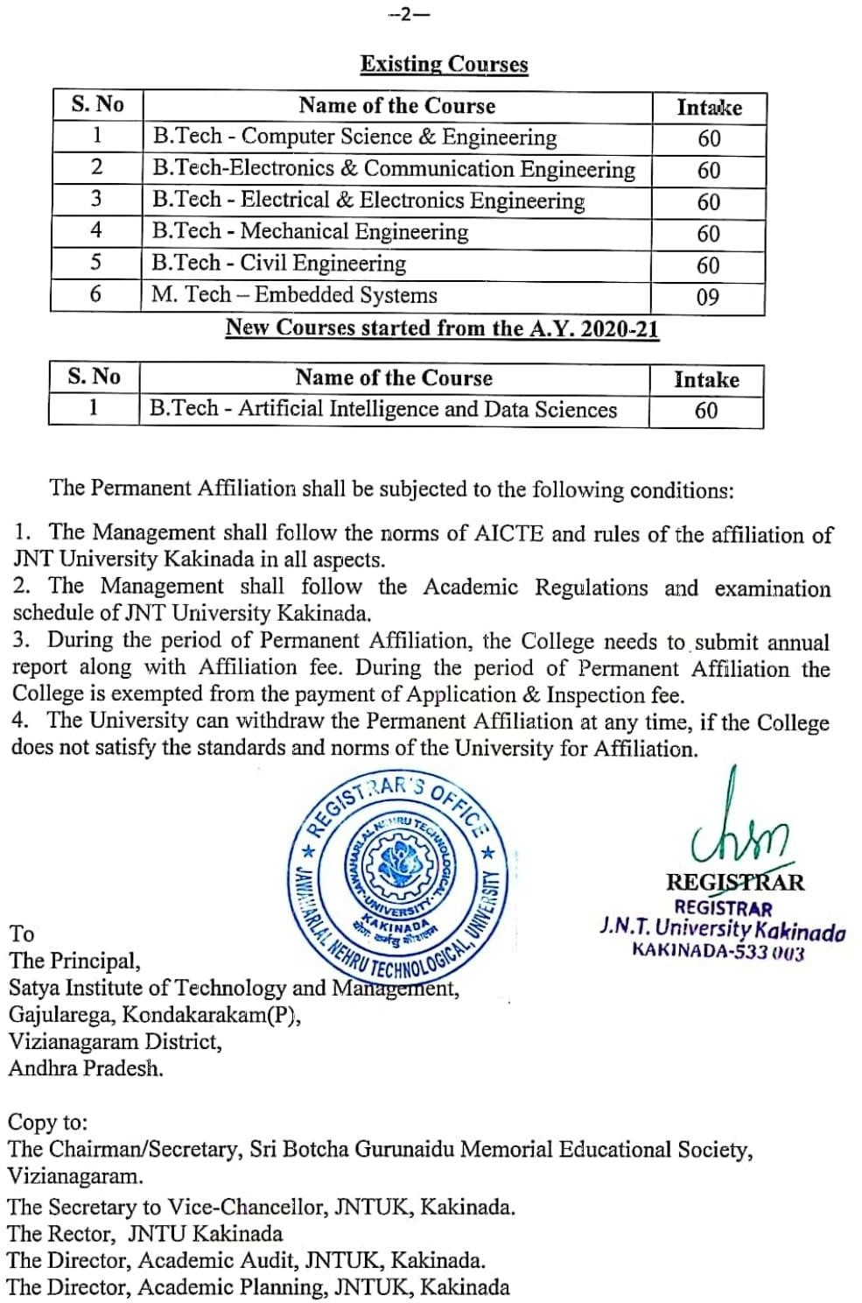

- 1. The following picture represents the order issued to Satya Institute of Technology and Management, regarding the new branch sanction from AICTE.

